Project Report

|  |  |
| --- | --- |
| **Course Name (NICF)** | **NICF Diploma in Infocomm Technology(Data)** |
| Product Name (Marketing & Sales) | Professional Diploma in Data Science |
| **Module Name (NICF)** | **NICF-Principles of Machine Learning(SF)** |
| Product Name (Marketing & Sales) | NICF-Principles of Machine Learning(SF) |

|  |  |  |  |
| --- | --- | --- | --- |
| Student name | | Assessor name | |
| Lee Jack Shiang | | Ryan Suryanto | |
| Date issued | Completion date | | Submitted on |
| 10-Aug-2022 | 16-Aug-2022 | | 16-Aug-2022 |
|  | |  | |
| Project title | Prediction of Regression Model using Azure Machine Learning Platform | | |



|  |
| --- |
| Learner declaration |
| I certify that the work submitted for this assignment is my own and research sources are fully acknowledged.  Student signature: Date: 16-Aug-2022 |

Content

1. Project Overview 2
2. Project Technical Environment 3
3. Analytical Technique & Tools used 4
4. Data Science Project Team – Roles and Responsibilities Table 6
5. Activity 1: Activity Summary 7
6. Activity 2: Flight DataSet- An Overview 9
7. Screen-shots of each task of Activity 3 10
8. Screen-shots of each task of Activity 4 11
9. Screen-shots of each task of Activity 5 12
10. Screen-shots of each task of Activity 6 14
11. Screen-shots of each task of Activity 7 16
12. Screen-shots of each task of Activity 8 29
13. Screen-shots of each task of Activity 9 31
14. Conclusion 34
15. Annexure - 01 35
16. Annexure - 02 38

Project Overview: Describe the Project with summary of analytical processes and project outcomes (Explain the Project in your own words in 15 – 20 lines)  
  
In this project, Azure Machine Learning (AML) studio is utilized for data pre-processing, and for subsequent training, evaluation, and deployment of a machine learning model as a web service for future predictions using Excel Online. The dataset which is used for this project is “Flight Delays Data”, a built-in dataset in AML studio. The built-in “Flight Delays Data” in AML studio consists of 2,719,418 rows (observations) and 14 columns (variables). A more detailed overview for this dataset is provided in Activity 2.  
  
For this project, a machine learning model which is aimed to predict how many minutes a flight will be delayed or early is built (hence the dependent variable is ArrDelay column of the dataset). Since ArrDelay is a variable of continuous value, this is a regression problem and the machine learning model shall be based on regression algorithm. However, prior to training the model, some data pre-processing (eg. joining of 2 datasets, data cleansing, standardization for selected numerical variables etc.) and some data visualization (using the Execute R Script module in AML studio) shall be done. After completing the data-preprocessing and data visualization, a regression model can be built in AML studio. Once the base regression model is built, several techniques (reverse engineering) which can be used for improving model’s performance, such as feature selection, handling of outliers, hyperparameter tuning etc. will be performed in order to get the optimal model. Subsequently, cross-validation will be performed for the optimal model to check if it is well generalized. Finally, the optimal model will be published as web service, and it will be used to predict the ArrDelay of the test data ‘Test-Flights.csv’ using Excel Online.

Project Technical Environment: (Describe the Microsoft Azure Machine Learning Platform)  
  
For this project, the following technical tools are used:  
1. Microsoft Azure Machine Learning Studio  
2. Microsoft Excel Online  
3. Microsoft Word  
  
Microsoft Azure Machine Learning (AML) studio is a workspace where we can create, build, train machine learning models. It is a drag and drop tool where we can drag the datasets and further process the analysis on that data. It offers both no-code and low-code options for projects. Codes written in Python, R or SQL for operations not offered by built-in AML modules are possible to be integrated into AML studio using the respective modules. The trained model in AML studio can be published as a web service and predictions can be made using Microsoft Excel Online. Finally, Microsoft Word is used for report preparation of this project.

1. Analytical Technique & Tools used : Describe the Analytical Technique (Regression) and Tools used in the Project  
     
   Regression is a statistical method, which is commonly used in many fields, such as finance, investing, engineering etc., for estimating the relationships between a dependent variable and one or more independent variables. For this project, the dependent variable is the ArrDelay column, and the independent variables are the remaining columns.  
     
   There are several regression model modules available in AML studio, such as:  
   i. Linear Regression:  
   Linear regression attempts to establish a linear relationship between one or more independent variables and a numeric outcome, or dependent variable. It is a good choice as it is a simple model and is preferred if interpretability of model is important.  
     
   ii. Boosted Decision Tree Regression:  
   Boosting is one of several classic methods for creating ensemble models, along with bagging, random forests, and so forth. In AML studio, boosted decision trees use an efficient implementation of the MART gradient boosting algorithm. Gradient boosting is a machine learning technique for regression problems. It builds each regression tree in a step-wise fashion, using a predefined loss function to measure the error in each step and correct for it in the next. Thus the prediction model is actually an ensemble of weaker prediction models.  
     
   iii. Decision Forest Regression:  
   Decision forest regression model consists of an ensemble of decision trees. In AML studio, each tree in a regression decision forest outputs a Gaussian distribution as a prediction. An aggregation is performed over the ensemble of trees to find a Gaussian distribution closest to the combined distribution for all trees in the model.  
     
   In this project, the three regression models above will be studied for finding the optimal model.   
     
   In addition to regression model modules, relevant modules / tools provided in AML studio are used for the following tasks:  
     
   a. For data-preprocessing:  
   As the original “Flight Delays Data” contains a lot of missing values and duplicate rows, the dataset shall be pre-processed in order to rectify them. This can be done by using the “Remove Duplicate Rows” and “Clean Missing Data” modules. In addition, as the original “Flight Delays Data” provides only the airport id (in digits) and without clearly specifies the respective airport locations and names, another built-in dataset “Airport Codes Dataset”, which contains the information for airport cities, states and names, will also be loaded and joined with the “Flight Delays Data” in order to produce a clearer dataset later on. Besides, before training the machine learning model, the selected numerical variables should be standardized using “Normalize Data” module (transformation method: ZScore) in order to have them on a similar scale.  
     
   b. For data visualization and statistical information:  
   Codes written in R can be integrated into AML studio environment by using the “Execute R Script” module. Those visualizations of interests (histograms, boxplots, scatterplots etc.) can be produced using either R’s built-in plots or visualization package ggplot2. Statistical information of the dataset can also be retrieved using codes written in R in a similar way.  
     
   c. For building machine learning model:  
   Prior to training the machine learning model, the cleansed data (after completing part a and b as described above) shall be split into train and test data using the “Split Data” module. Subsequently, the train data shall be used for training the model using “Train Model” module. Since the dependent variable for this project is ArrDelay, a variable of continuous value, and its known labels (actual values from historical data), hence this is a regression problem of supervised machine learning.  
   For this project, “Boosted Decision Tree Regression” is chosen as the regression algorithm and is used to train the base model. After the base model is built, several techniques (reverse engineering) such as feature selection, handling for outliers, hyperparameter tuning etc. will be performed in order to get the optimal model. Cross-validation for the optimal model will also be performed for checking if it is well generalized.  
     
   d. For publishing the optimal model as web service:  
   Once the machine learning stage is complete, the optimal model can be published as web service via the “Set Up Web Service” at the bottom of AML studio. Once the optimal model is successfully deployed and shared with others, it can readily be used for future predictions using Excel Online.

1. Data Science Project Team – Roles and Responsibilities Table  
     
   Data science is the domain of study that deals with vast volumes of data using modern tools and techniques to find unseen patterns, derive meaningful information, and make business decisions.  
   Today, data science has become an essential part of many industries, given the massive amounts of data that are produced. Its popularity has grown over the years, and companies have started implementing data science techniques to grow their business and increase customer satisfaction. As such, many companies have their own dedicated data science teams, which is responsible for helping their business leaders to make sound and data-driven business decisions.   
   The data science team of a company consists of many personnel, and each role within the team will require different specialties. In order to successfully run a data-driven business, it is crucial for the company to understand the roles and responsibilities of their data science team. The tables below summarize the required skill sets and main responsibilities for some common roles in a data science team.  
     
   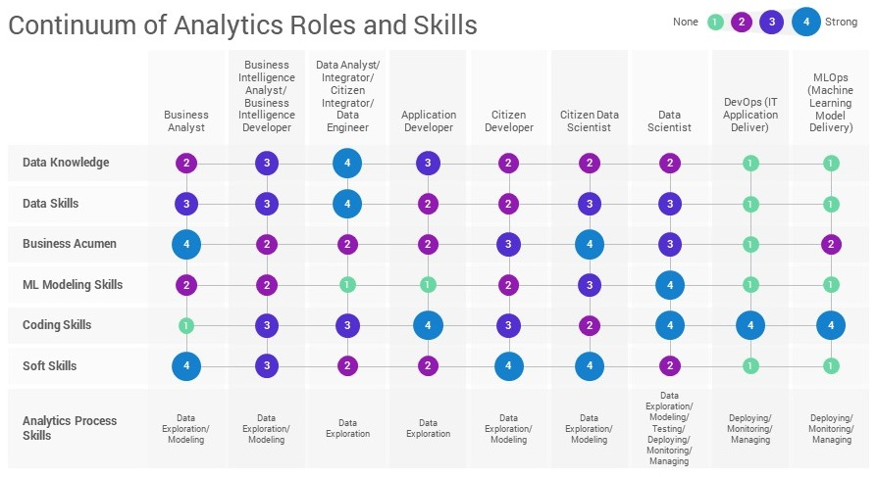  
     
   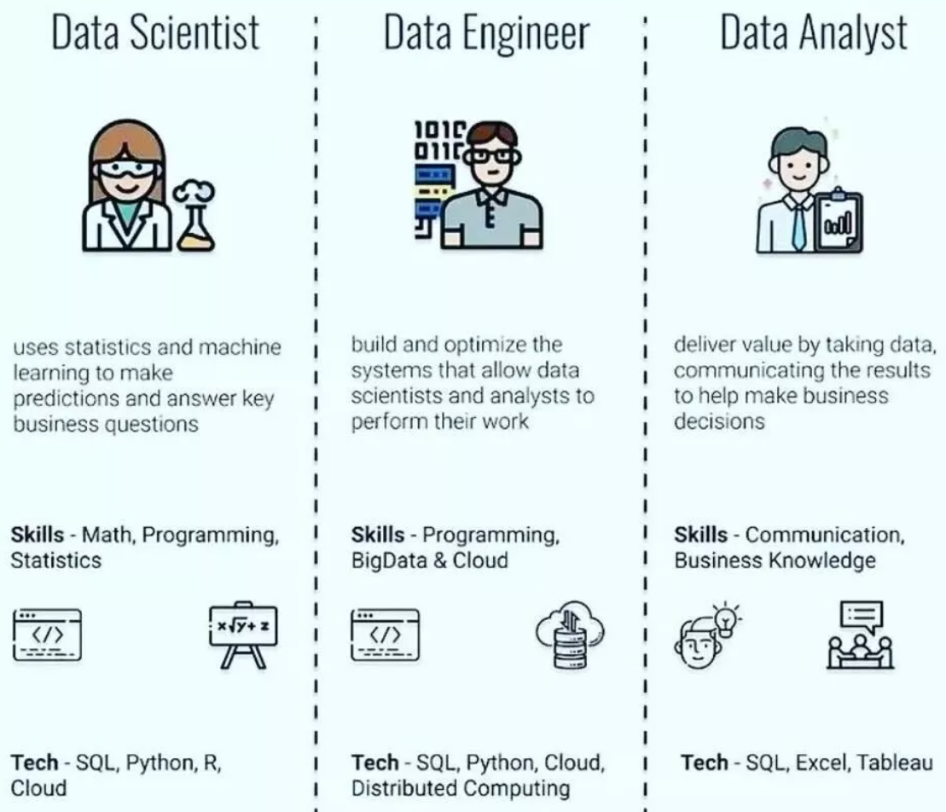
2. Activity 1: Activity Summary

This project is divided into 4 parts and details of each part are elaborated in the table below:

|  |  |
| --- | --- |
| Part 1: Preparatory Activities | |
| Activity 1 | Please refer page 6 for roles and responsibilities of a data science team. Please refer the details for each activity of this project provided in this section. |
| Activity 2 | “Flight Delays Data” in AML studio which is used for this project consists of 2,719,418 rows (observations) and 14 columns (variables). |
| Part 2: Data Cleansing Activities | |
| Activity 3 | A new experiment named “PML0322A-Lee Jack Shiang-Project” is created in AML studio. “Flight Delays Data” is loaded, and it consists of 2,719,418 rows (observations) and 14 columns (variables). The mean value of ArrDelay column is 6.6377. |
| Activity 4 | Another dataset “Airport Codes Dataset”, is loaded and joined with “Flight Delays Data” in order to show more details of airports (cities, states and names). Based on the joined dataset, it is found that “Hartsfield-Jackson Atlanta International” is the most frequently occurring destination airport in the dataset. |
| Activity 5 | Rows with matching values for all the following fields are considered duplicated and removed:  Year, Month, DayofMonth, Carrier, OriginAirportID, DestAirport ID, CRSDepTime and CRSArrTime After removing the duplicate rows, those missing values in the DepDelay and ArrDelay columns are replaced with value 0 (zero). The resultant dataset is left with 2,719,397 rows and 22 columns. The mean value of the ArrDelay column now becomes 6.5669. |
| Part 3: Data Exploration Activities | |
| Activity 6 | For this part, codes written in R are integrated with the AML studio environment. Some functions of R, such as summary() and sd(), are utilized to obtain the statistical summary of the ArrDelay column: Minimum: -94 Mean: 6.567 Standard Deviation: 38.44812 Maximum: 1845 |

|  |  |
| --- | --- |
| Part 4: Perform Machine Learning Activities | |
| Activity 7 | A base regression model is created, which is aimed to predict the value of ArrDelay (dependent variable) based on the following selected features (independent variables): - Month, DayofMonth, DayOfWeek, Carrier, OriginAirportID, DestAirportID, CRSDepTime, DepDelay and CRSArrTime Prior to training the model, the OriginAirportID, DestAirportID and Carrier columns are converted to Categorical. In addition, CRSDepTime, CRSArrTime and DepDelay columns are standardized using ZScore transformation method in order to make them on a similar scale. The final dataset is then split into train (70%) and test (30%) sets with random seed value of 0. The base regression model is then trained with the train data, and the algorithm chosen for base regression model is “Boosted Decision Tree Regression”. The trained model is then scored and evaluated based on the test data. Once the base regression model is built, several techniques (reverse engineering) for improving the model performance will be performed in order to get the optimal model. Cross validation for the optimal model will also be performed to check if it is well generalized. |
| Activity 8 | After getting the optimal model, performances of the base and the optimal models will be compared over several metrics, such as Coefficient of Determination, Root Mean Squared Error etc., to check if any significant performance improvement from the optimal model. Below are the metrics of the base regression model (left) and the optimal model (right):    It is found that the Root Mean Squared Error (RMSE) and Coefficient of Determination of the optimal model are significantly improved. |
| Activity 9 | The optimal model is ready for publish as web service (Predictive Experiment). For this web service, only the “Scored Labels” (the predicted values of ArrDelay) column will be the output. After saving and running the Predictive Experiment, the optimal model can be deployed and used for the prediction of ArrDelay of the test data ‘Test-Flights.csv’ using Excel Online. The optimal model is found capable of correctly predicting ArrDelay within 10 minutes of the actual delay time for 23 out of 25 rows. |

1. Activity 2: Flight DataSet- An Overview

The dataset which is used for this project is the “Flight Delays Data”, a built-in dataset in AML studio. It consists of 2,719,418 rows (observations) and 14 columns (variables) of air flight data collected in 2013 from various airports in the United States.

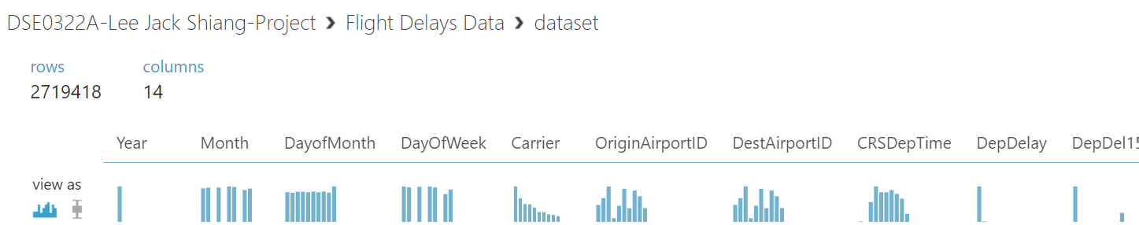

The 14 columns of the dataset are:  
Year: Year  
Month: Month  
DayofMonth: Day of the month  
DayOfWeek: Day of the week  
Carrier: Code assigned by IATA (International Air Transport Association) and commonly used to identify a carrier  
OriginAirportID: An identification number assigned by US DOT (Department of Transportation) to identify a unique airport (the flight’s origin)  
DestAirportID: An identification number assigned by US DOT to identify a unique airport (the flight’s destination)  
CRSDepTime: The CRS departure time in local time (hhmm)  
DepDelay: Difference in minutes between the scheduled and actual departure times. Early departures show negative numbers  
DepDel15: A Boolean value indicating whether the departure was delayed by 15 minutes or more (1 = Departure was delayed)  
CRSArrTime: CRS arrival time in local time (hhmm)  
ArrDelay: Difference in minutes between the scheduled and actual arrival times. Early arrivals show negative numbers  
ArrDel15: A Boolean value indicating whether the arrival was delayed by 15 minutes or more (1 = Arrival was delayed)  
Cancelled: A Boolean value indicating whether the arrival flight was cancelled (1 = Flight was cancelled)  
  
As the aim of the machine learning model of this project is to predict how many minutes a flight will be delayed or early, the dependent variable is the ArrDelay column of the dataset.

1. Screen-shots of each task of Activity 3: Create New Experiment

Task 1: Sign in to Azure Machine Learning Workspace

Task 2: Create a new experiment, with an appropriate name like "Flights Challenge".

Task 3: Add the Flights Delay Data sample dataset to the experiment, and then visualize its contents.

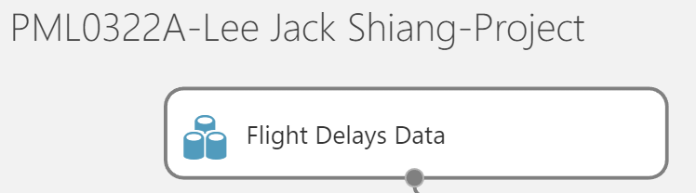

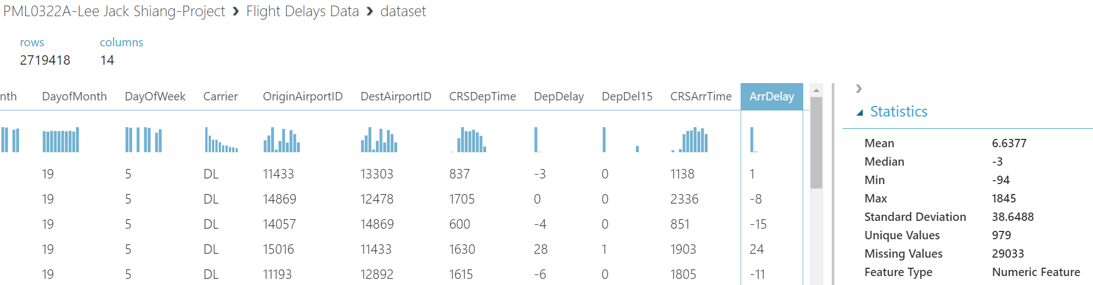

Task 4: Answer the following questions:

- How many rows are in the dataset?

2,719,418

- What is the mean value of the ArrDelay column?

6.6377

1. Screen-shots of each task of Activity 4: Join the Airport Codes Dataset

Task 1: Create two joins; one to join the origin airport and one to join the destination airport. Use built-in Azure Machine Learning Join Data modules to accomplish this, or use custom SQL or R code. The resulting joined dataset should contain the original flight data as well as the name, city, and state for both the origin and destination airports.

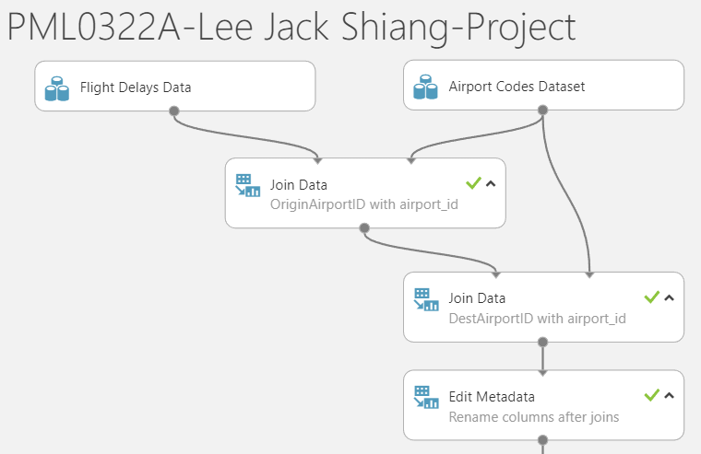

Task 2: After joining the datasets, visualize the joined data.

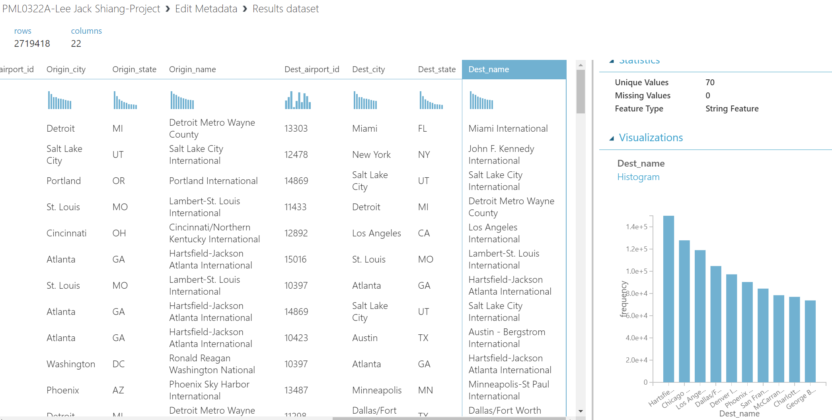

Task 3: Answer the following questions: Which is the most frequently occurring destination airport in the dataset.

Hartsfield-Jackson Atlanta International

1. Screen-shots of each task of Activity 5: Remove Duplicates and Replace Missing Values

Task 1: Remove duplicate rows (retaining the first instance of each row). Rows are considered duplicates in this dataset if they have matching values for all the following fields:

- Year

- Month

- DayofMonth

- Carrier

- Origin Airport ID

- Dest Airport ID

- CRS Dep Time

- CRS Arr Time

Use the built-in Azure Machine Learning module, or custom SQL or R script to accomplish this.

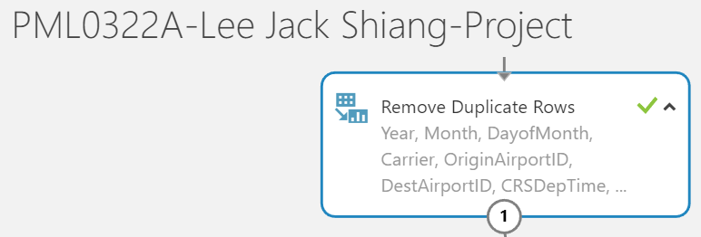 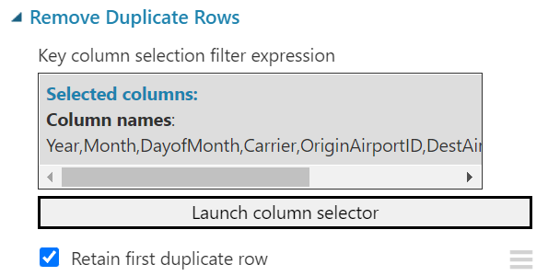

Task 2: After removing the duplicate rows, replace missing values in the DepDelay and ArrDelay columns with the value 0 (zero). Use the built-in Azure Machine Learning Remove Duplicate Rows module, or custom SQL or R script to accomplish this.

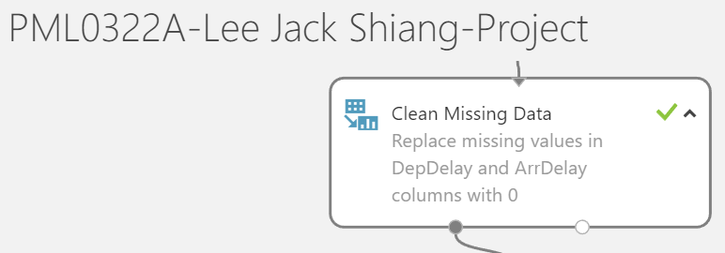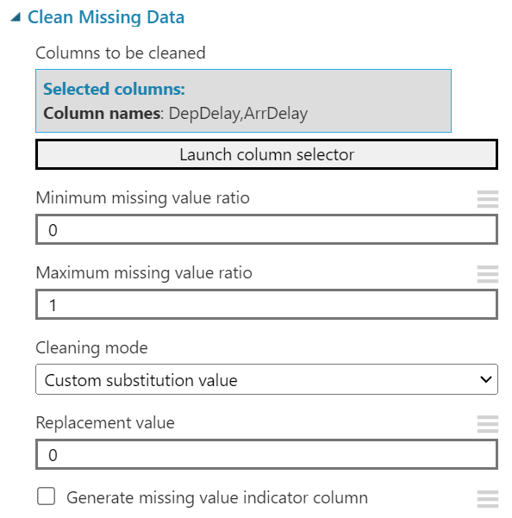

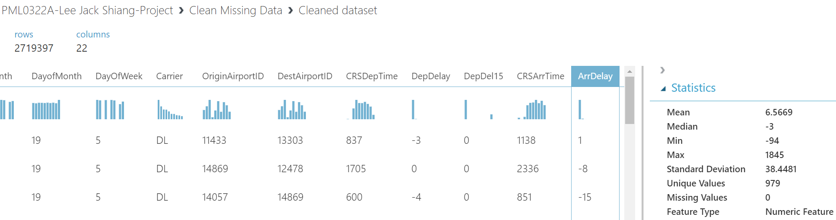

Task 3: Answer the following questions, after you have removed duplicate rows and replaced missing values,

- How many rows remain in the dataset?

2,719,397

- What is the mean value of the ArrDelay column?

6.5669

It is required to handle those duplicate rows and missing values of a dataset prior to training the machine learning model as:

1. Many machine learning algorithms do not work with missing values. To avoid any errors or unexpected outcomes during model training, those missing values must be handled beforehand.
2. Duplicate rows mean feeding the same information to the model again and again when it is being trained. This will result in a biased and overfitted model.
3. Screen-shots of each task of Activity 6: View Summary Statistics

Task 1: Open the Azure Machine Learning experiment that was used to cleanse the flight data.

Task 2: Add a Convert to CSV module to the last existing module and run the experiment

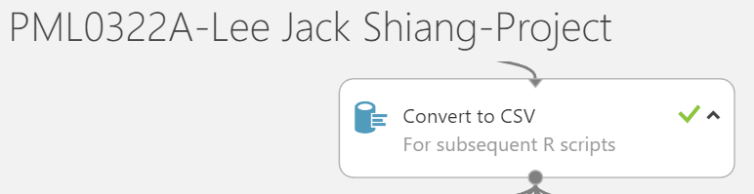

Task 3: Right-click the output of the Convert to CSV module and open the dataset in a new notebook using R

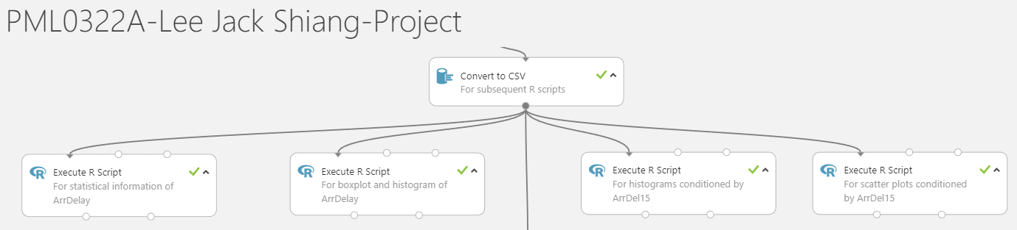

Task 4: After the notebook has opened, run the existing cells (which are generated automatically) to load and view the DataFrame. Tip: Rename your notebook to something more meaningful (like "Explore Flight Data"). This will help you find it again if you want to reopen it later

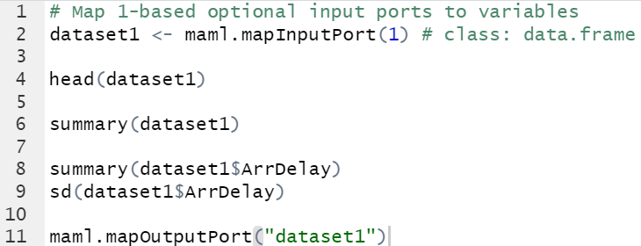

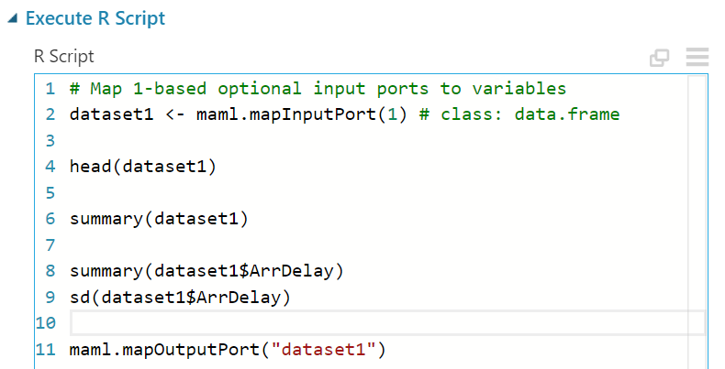

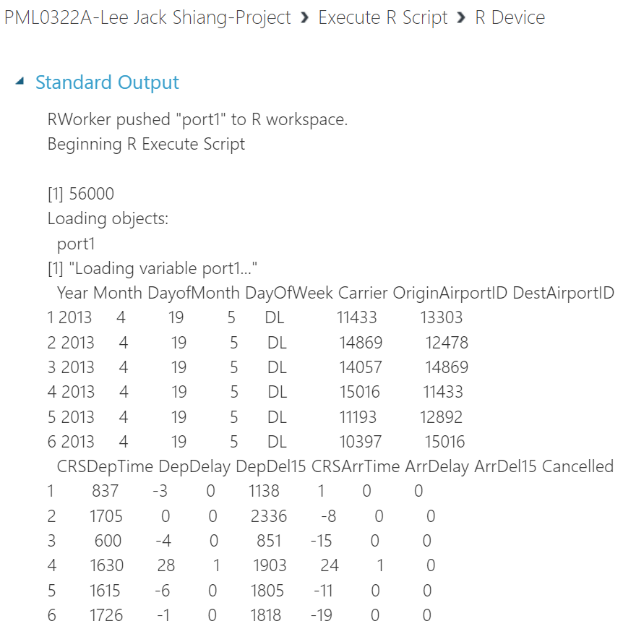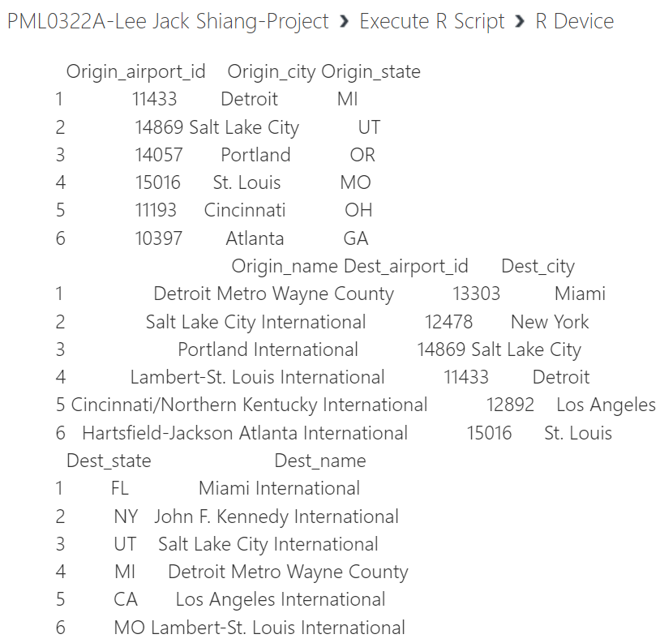

Task 5: Use the R summary and sd functions to display summary statistics for all columns in the DataFrame containing the flights data.

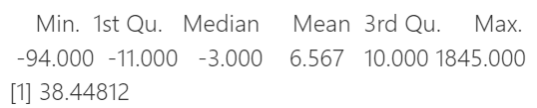

Task 6: Determine the following summary values for the ArrDelay column:

- Minimum

-94.0

- Mean

6.567

- Standard Deviation

38.44812

- Maximum

1845.0

1. Screen-shots of each task of Activity 7: Train a Regression Model

- Task 1: Return to the Azure Machine Learning experiment you created in Part 1.

- Task 2: Add a Select Columns in Dataset module, and use it to select only the Month, DayofMonth, DayOfWeek, Carrier, OriginAirportID, DestAirportID, CRSDepTime, DepDelay, CRSArrTime, and ArrDelay columns.

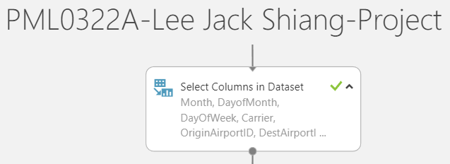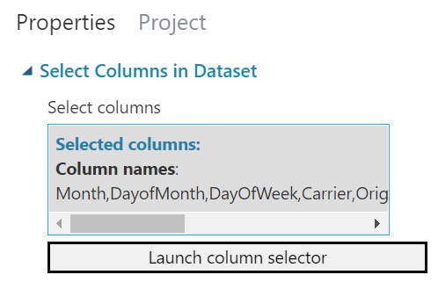

- Task 3: Add an Edit Metadata module and use it to make the OriginAirportID, DestAirportID, and Carrier columns Categorical.

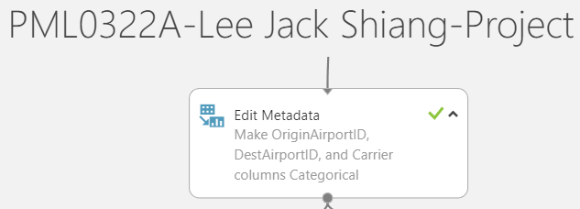

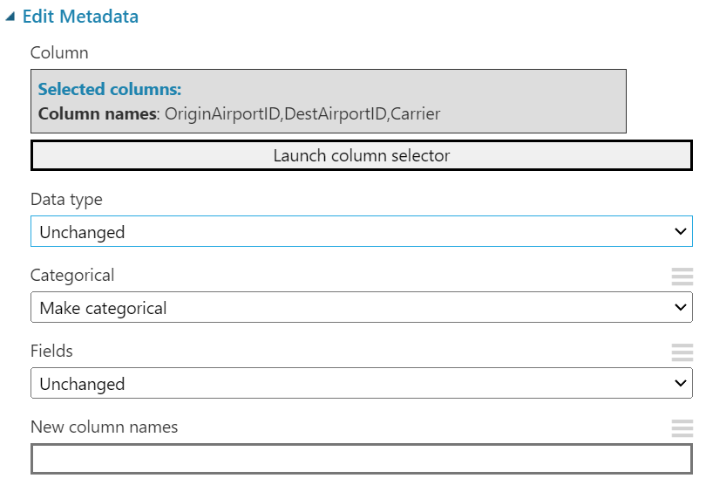

- Task 4: Add a Normalize Data module and use it to standardize the CRSDepTime, CRSArrTime, and DepDelay columns using the ZScore transformation method.

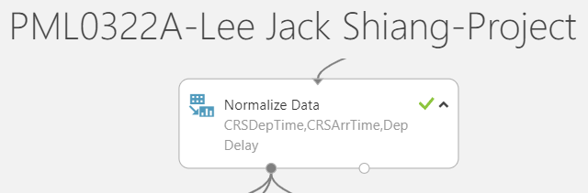

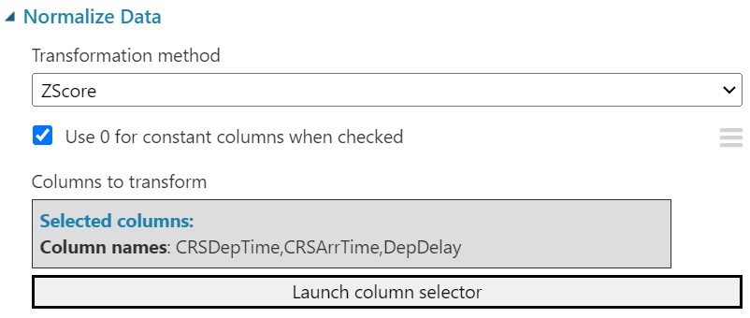

The reason to standardize these numerical variables is to have them on a similar scale. Variables that are measured at different scales do not contribute equally when training the machine learning model and this may end up with a biased model (eg. a variable that ranges between 0 and 1000 will outweigh a variable that ranges between 0 and 1).

- Task 5: Add a Split Data module and use it to split the rows into 70% / 30% subsets. Use a random seed value of 0.

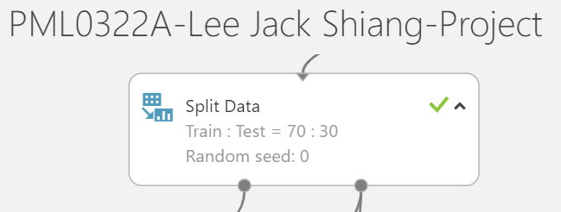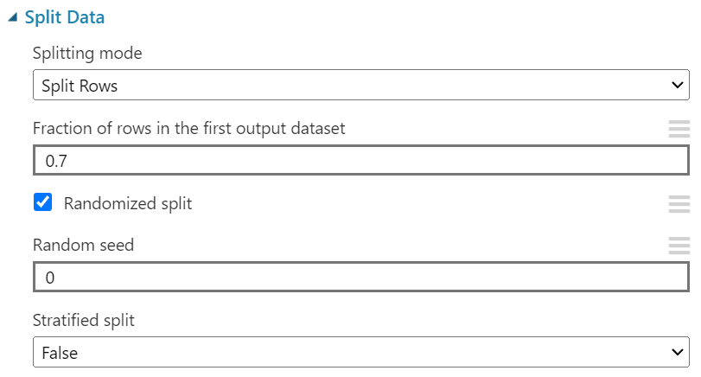

The purpose of the train-test split is to estimate the performance of a machine learning model when it is used for making predictions based on real world data for which the trained model has not seen before. In addition, train-test split can also help to minimize overfitting and the accuracy of the model based on test data can be directly compared with the accuracy based on train data. If the model’s accuracy on the test data is much worse than that of on the train data, then the model is overfitted during training. This check for overfitting is not possible if there is no train-test split.

- Task 6: Add a Boosted Decision Tree Regression module and a Train Model module. Then use the default settings to train the model with the 70% data split to predict the ArrDelay label column.

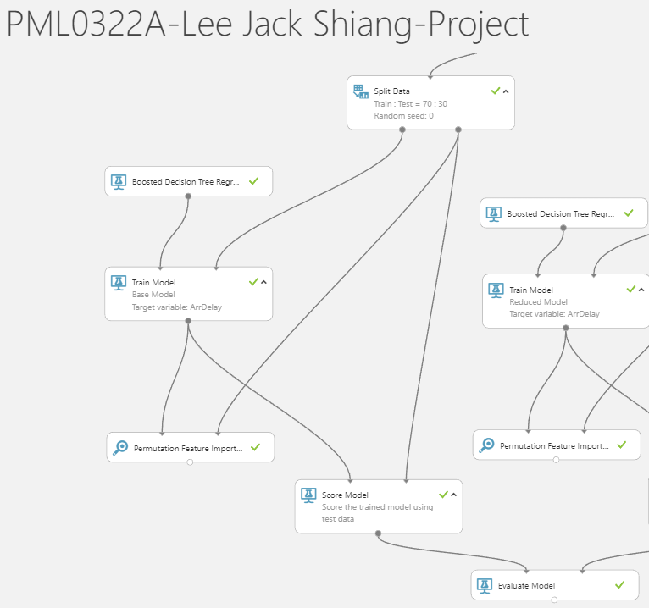

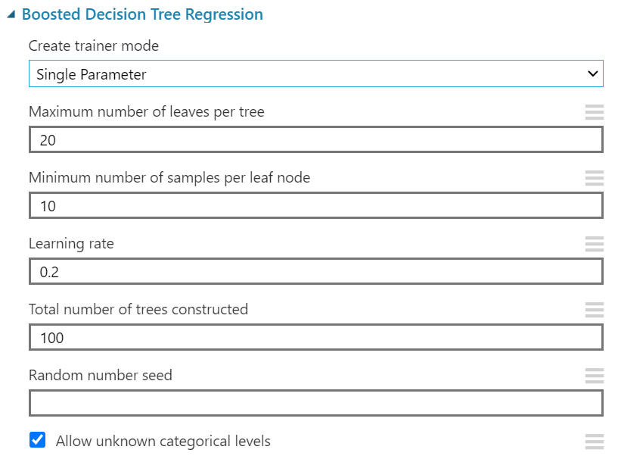

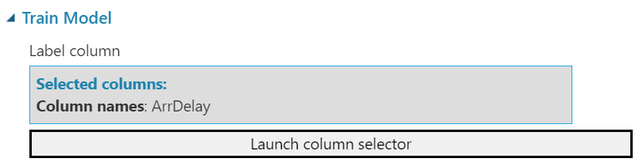

- Task 7: Add a Score Model module, and use it to score the trained model using the 30% split of data.



Score Model based on test data:

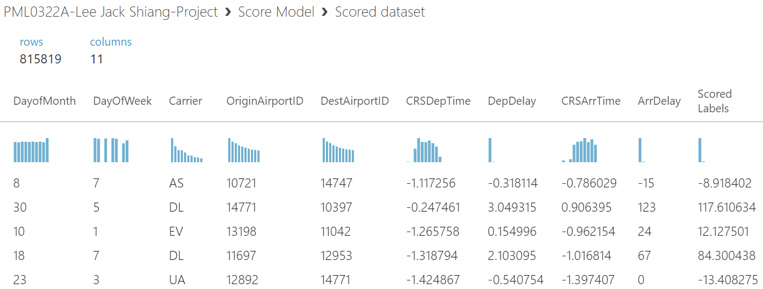

- Task 8: Add an Evaluate Model module and use it to evaluate the results from the Score Model module



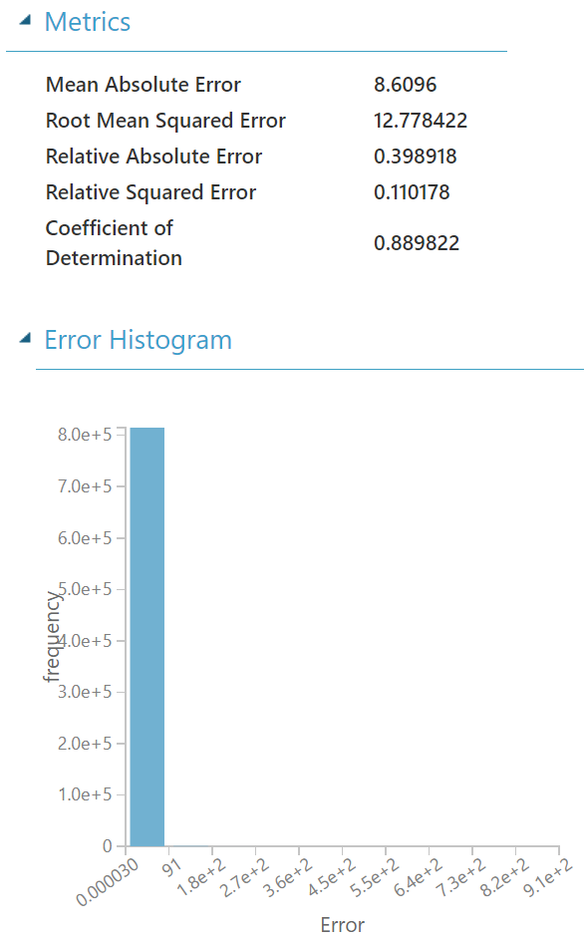

Additional Task: Improving the Machine Learning Model

In this section, several techniques (reverse engineering), such as feature selection, using different algorithms for the regression task, handling of outliers, and hyperparameter tuning will be used for obtaining the optimal model. Subsequently, we will use cross-validation for verifying that the optimal model is indeed generalized well and ready for prediction using real world data. In the next few pages, each step for obtaining the optimal model will be presented.

Step 1: Feature selection of the base model

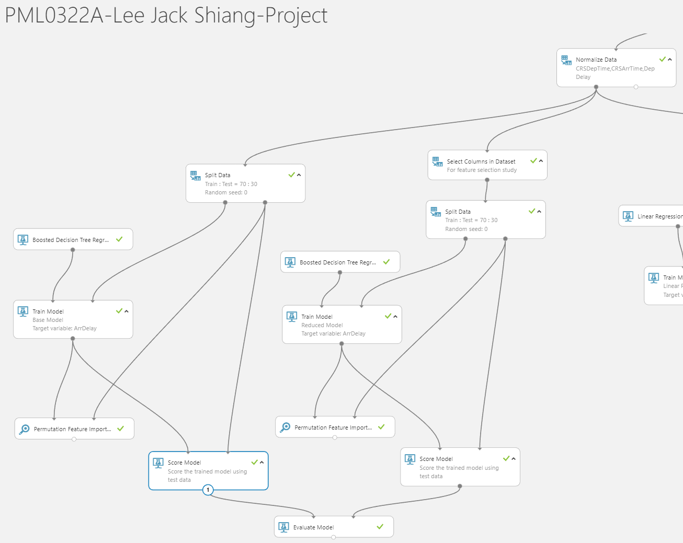

In this step, features of the base model are dropped sequentially (start from the least important) based on their importance found using the ‘Permutation Feature Importance’ module. The reduced model’s Coefficient of Determination, and its respective change from the base model’s Coefficient of Determination are recorded in the following table:



From above it is clear that all features are not crucial for predicting ArrDelay, except DepDelay.

Step 2: Comparison of performance using different algorithms

In this step, a linear regression and a decision forest regression model are built for checking their performances with the base model (boosted decision tree regression).

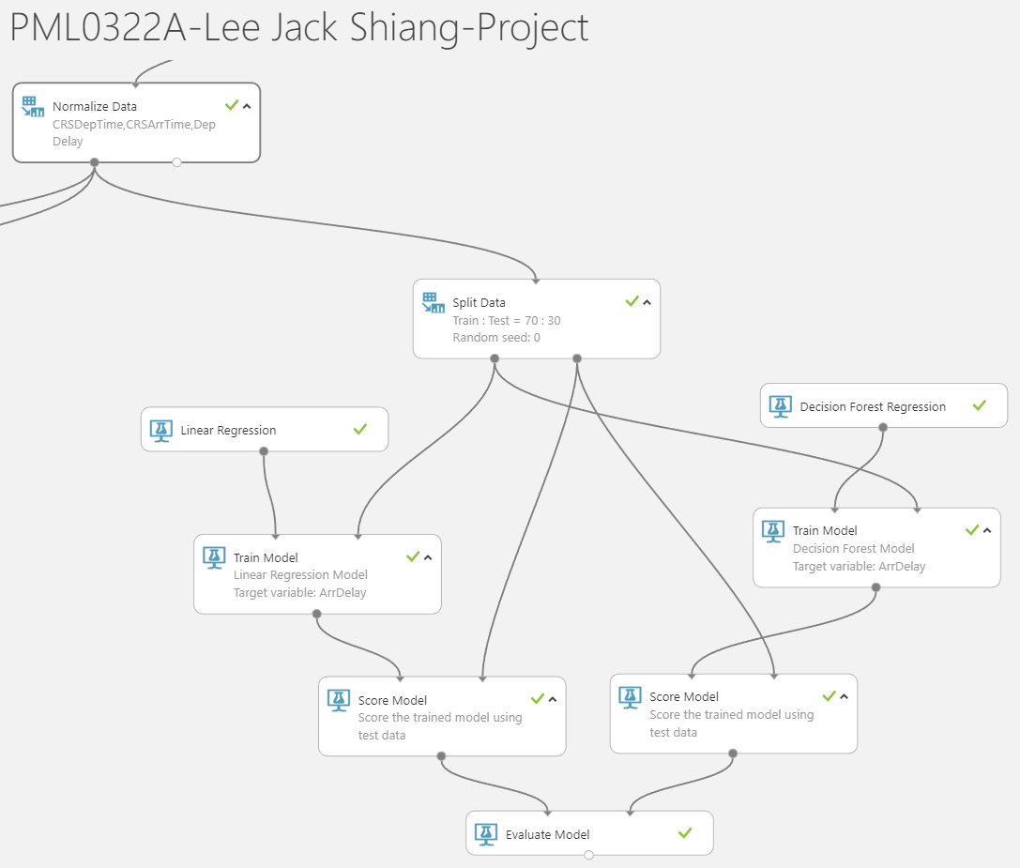

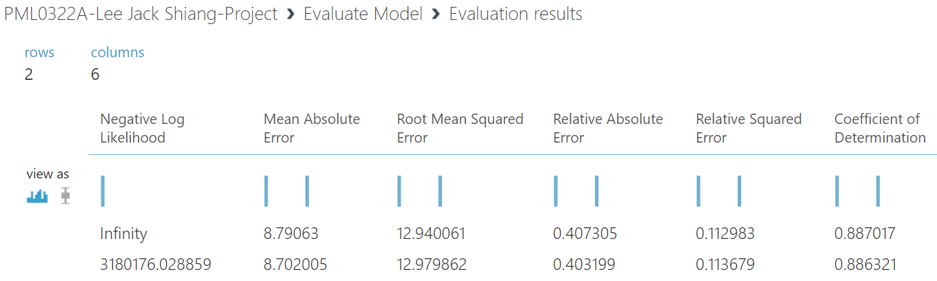

From above it is shown that both linear regression and decision forest regression are no better. Hence only boosted decision tree regression will be used for further study.

Step 3: Handling outliers

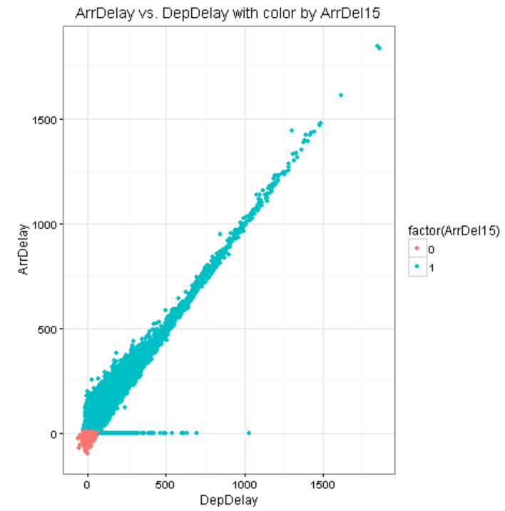

From the visualization above, it is clear that there are some outliers along the horizontal axis when ArrDelay = 0 (does not really make sense when DepDelay is so large yet there is no ArrDelay). For handling these outliers, the ‘Apply SQL Transformation’ module will be utilized. An observation is considered as an outlier if its difference of (ArrDelay – DepDelay) is less than -30.27 or more than 22.54 (±2 standard deviations away from the mean value). In this case the ArrDelay of this observation will be set equal to its DepDelay value.

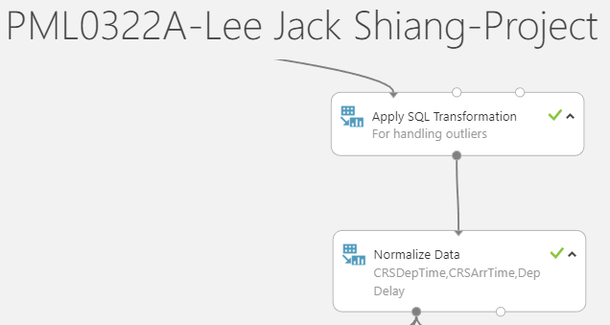



SQL code in the ‘Apply SQL Transformation’ module for handling outliers:



Metrics for the base model after handling outliers:

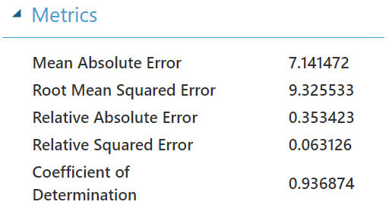

From above, it is clear that the performance of the base model has been improved substantially (Coefficient of Determination up from 0.889822 to 0.936874) after handling those outliers.

Step 4: Feature selection of the base model (after handling outliers)

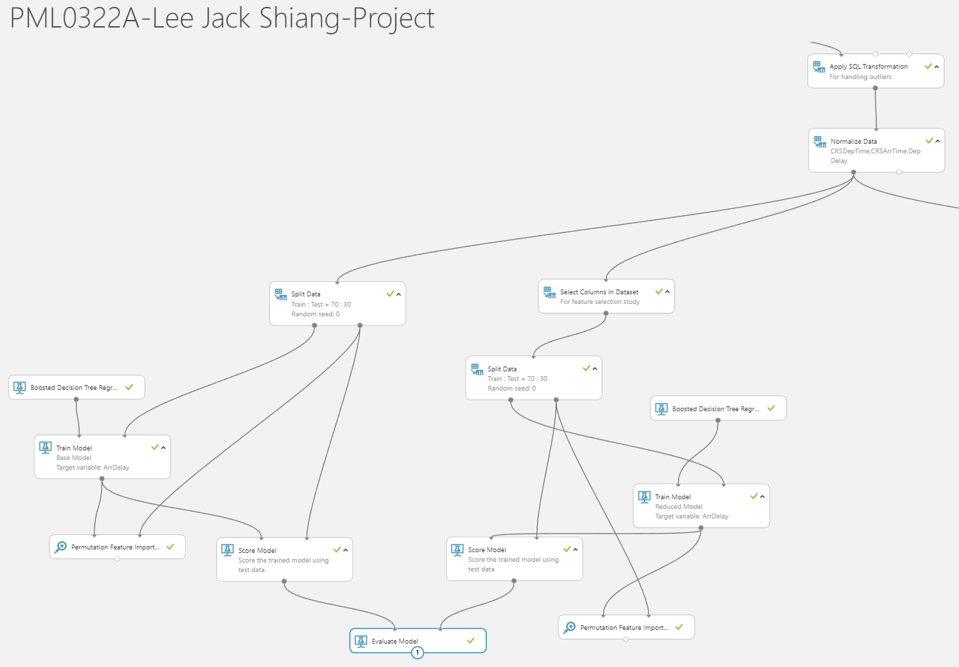

In this step, features of the base model are dropped sequentially (start from the least important) based on their importance found using the ‘Permutation Feature Importance’ module. The reduced model’s Coefficient of Determination, and its respective change from the base model’s Coefficient of Determination are recorded in the following table:



From above, again all features are not crucial for predicting ArrDelay, except DepDelay, after handling outliers. Column ‘DayOfWeek’ will be dropped since it has negligible effects for predicting ArrDelay and the reduced model will be used for subsequent hyperparameter tuning.

Step 5: Hyperparameter tuning for the reduced model from Step 4

As mentioned in Step 4, column ‘DayOfWeek’ will be dropped:

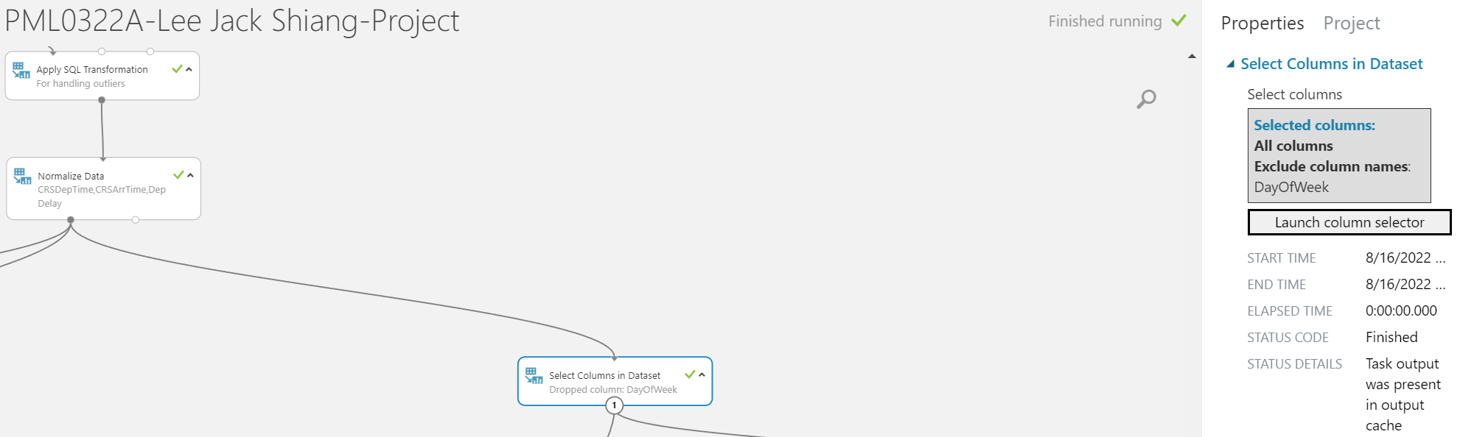

‘Tune Model Hyperparameters’ module will be utilized for random sweeping of those parameter range specified in the ‘Boosted Decision Tree Regression’ module in order to find the optimal model (or at least an improvement):

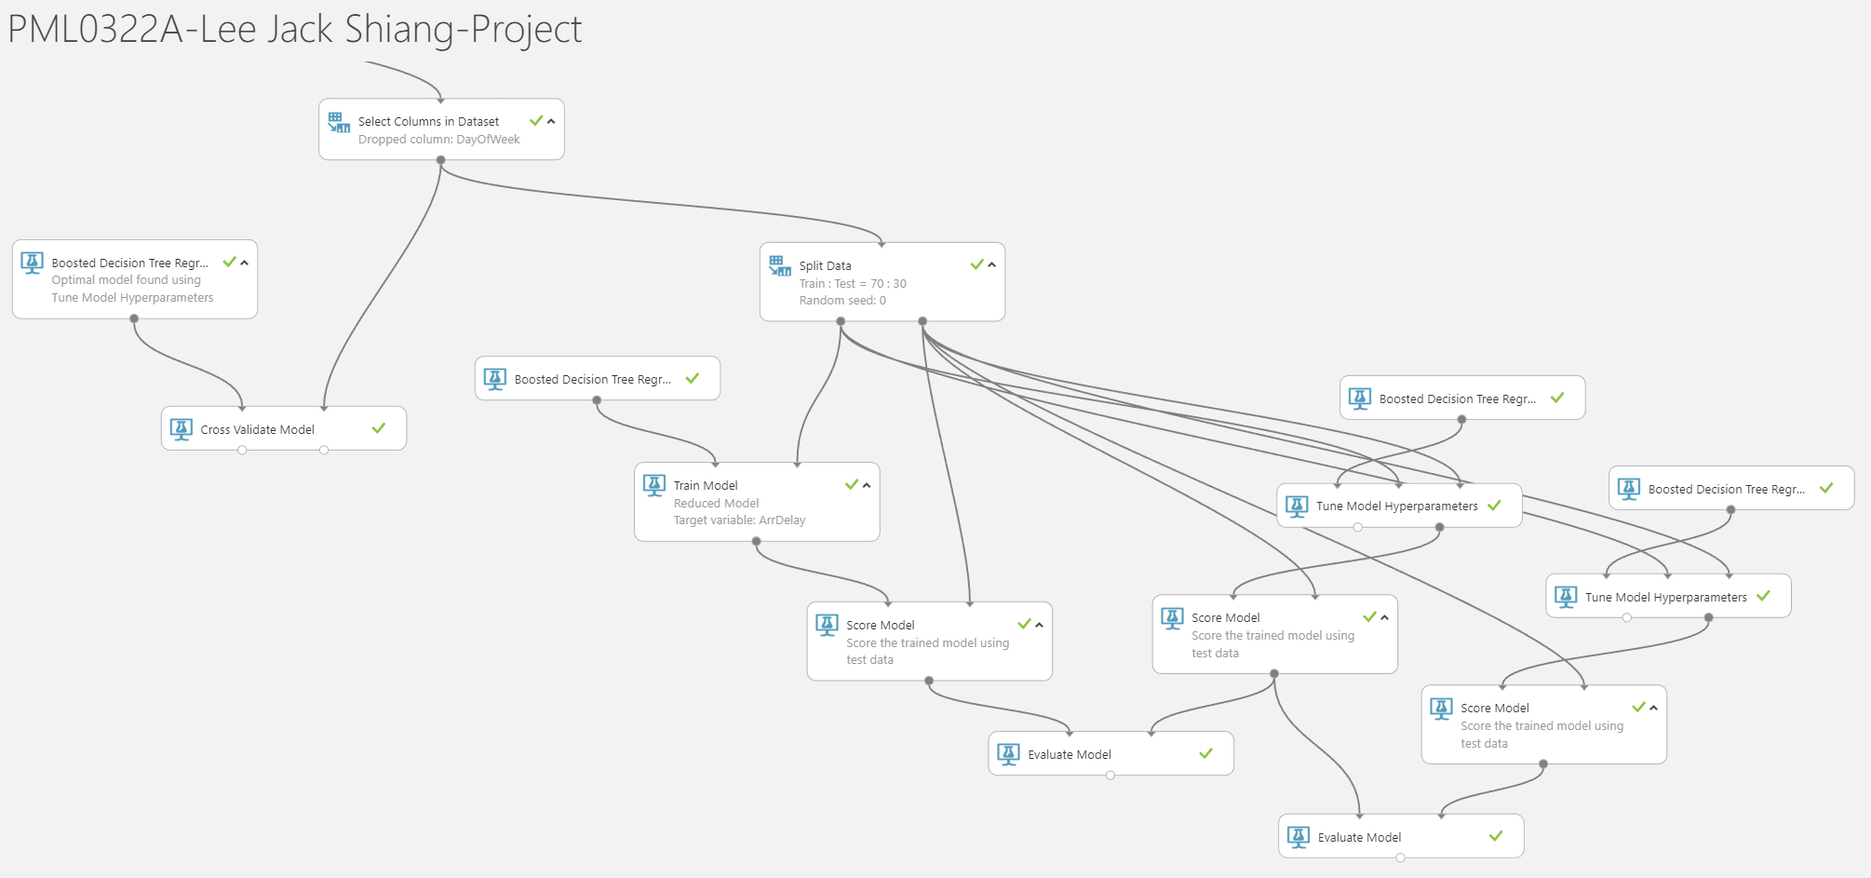

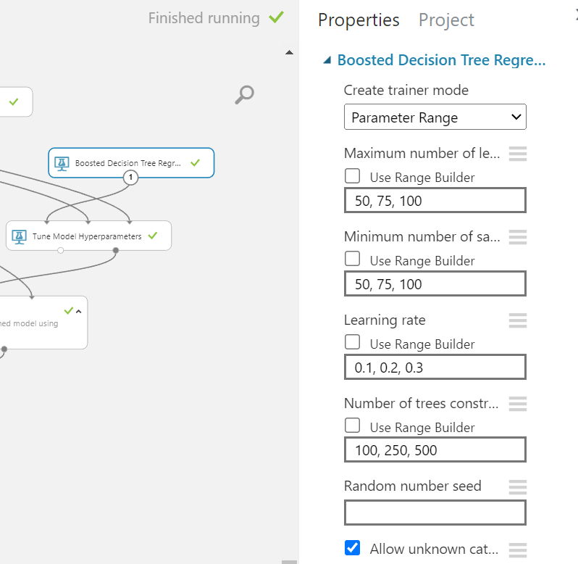 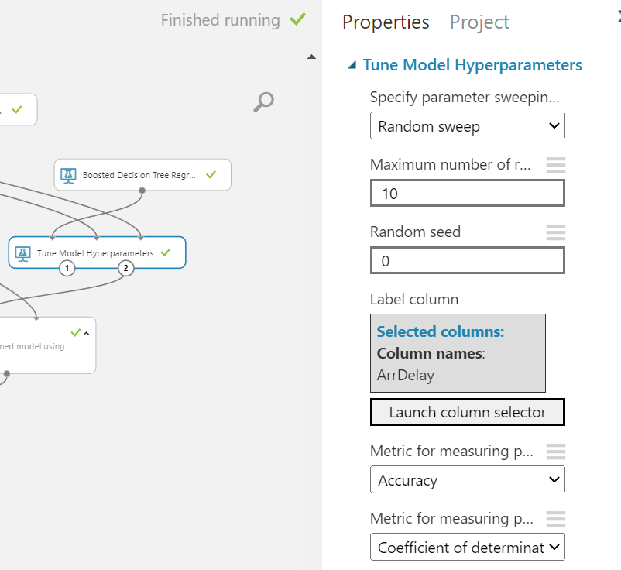

Check the sweep results of the random sweeping:

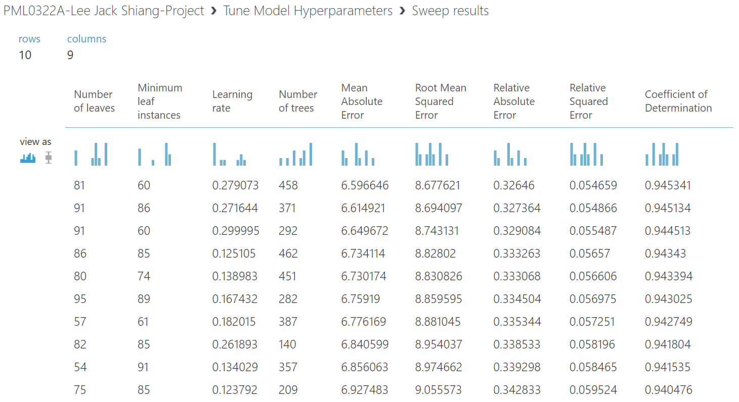

From above, we can see that there is an improvement to the base model (0.936874). Hence, the set of hyperparameter which gives the best improvement will be used for the optimal model.

Step 6: Cross-validation check for the optimal model

‘Cross Validate Model’ module will be utilized for performing the cross validation of the optimal model obtained from Step 5. Cross-validation is a useful method for flagging either overfitting or selection bias in the training data. It is also useful for measuring if the optimal model is generalized well.

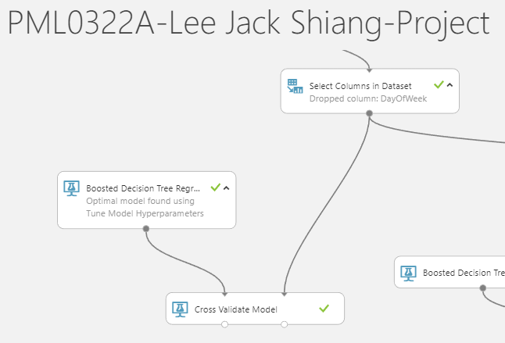 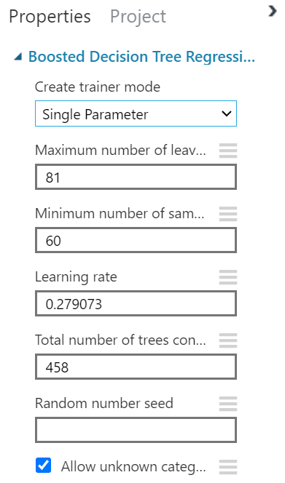

Metrics of the optimal model for the 10-fold cross-validation:

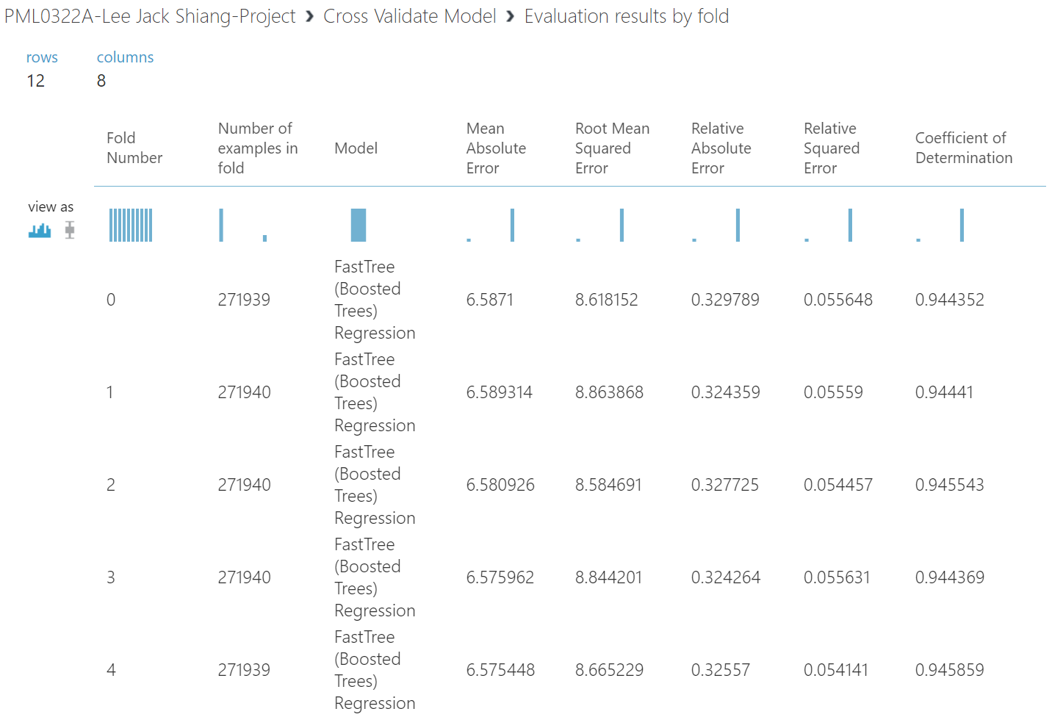

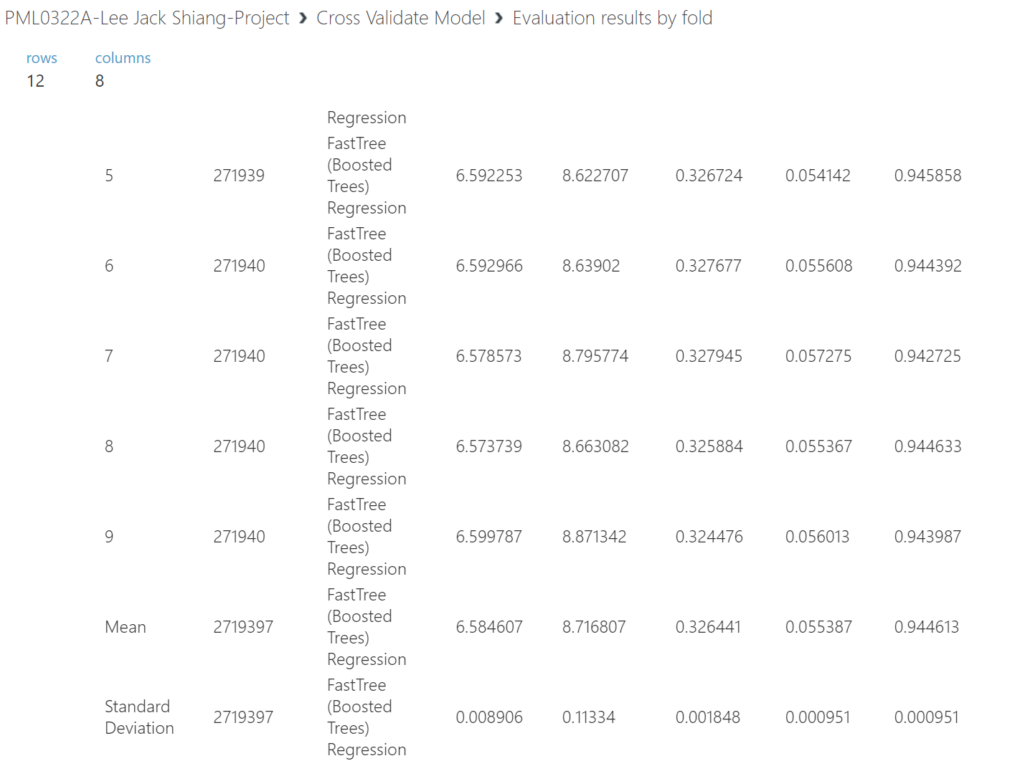

From the results of cross-validation above, we can see that the Root Mean Square Error and Coefficient of Determination across all 10 folds are fairly consistent. This can also be shown by the fact that the standard deviation is very small compared to the respective mean value. Hence from the results of the cross-validation above, the optimal model should be well generalized for real world data.

1. Screen-shots of each task of Activity 8: Monitor and Evaluate the Model

Task 1: Run the experiment,

Task 2: When it has finished, visualize the output of the Evaluate Model module. There are numerous metrics that you can use to evaluate a regression model, including the Root Mean Squared Error (RMSE), which indicates the mean variance between predicted and actual label values, in this case, the number of minutes on average by which predicted flight delays vary from actual flight delays.

RMSE is one of the most commonly used measures for evaluating the quality of predictions. It shows how far predictions fall from measured true values using Euclidean distance and it can be expressed as

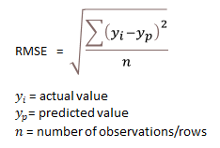

The coefficient of determination (R² or r-squared) is a statistical measure in a regression model that determines the proportion of variance in the dependent variable that can be explained by the independent variable.

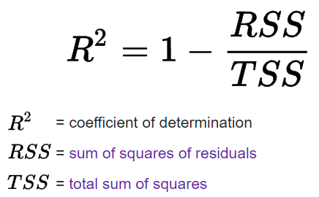

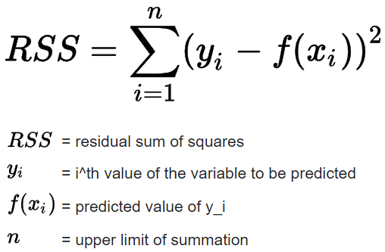 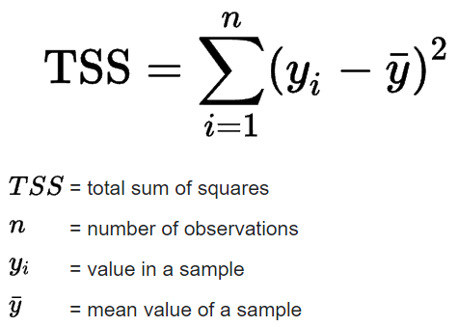

If the problem is multivariate (more than 1 independent variable), adjusted R² shall be used and it is given by the expression below:  
  
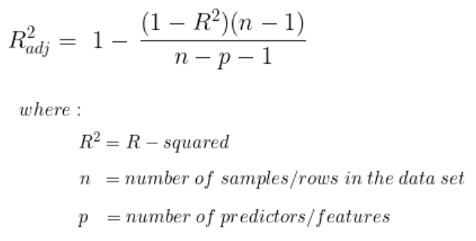

Comparison for metrics of the base model vs the optimal model:

Base model:

* Not handling outliers
* Not dropping any feature
* Using the default hyperparameter setting for the boosted decision tree regression module

Optimal model:

* Handling outliers
* Dropping ‘DayOfWeek’ column
* Using the optimal setting found from hyperparameter tuning for the boosted decision tree regression module

Metrics of the base model: Metrics of the optimal model:

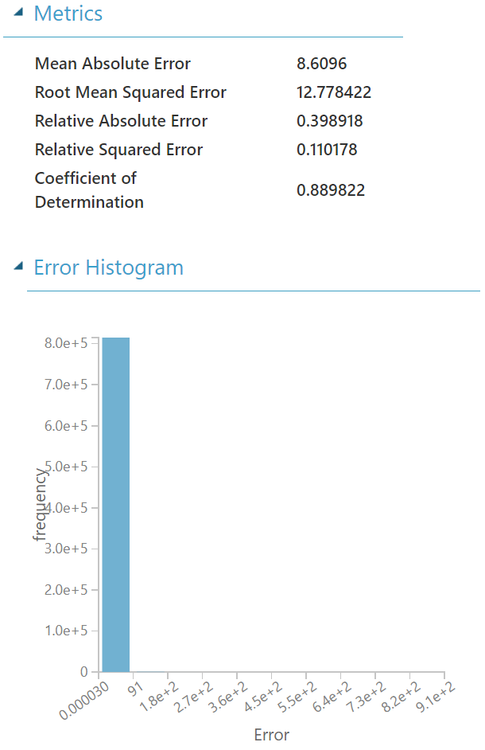 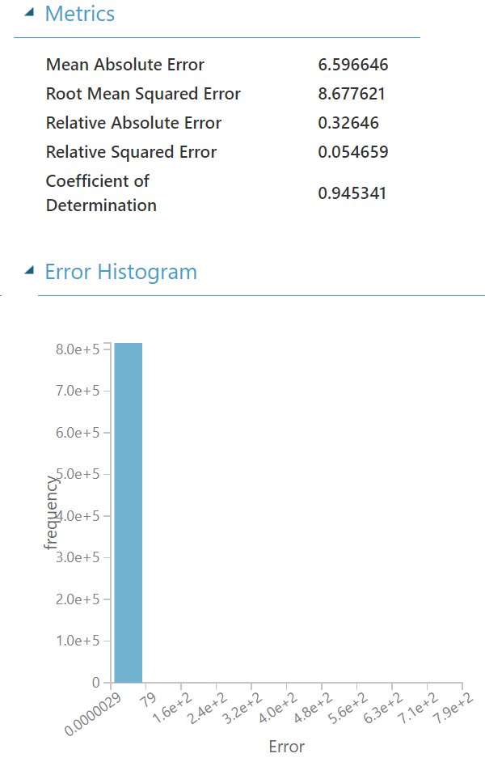

Task 3: Determine the Root Mean Squared Error for the model.

Root Mean Squared Error for the base model: 12.778422

Root Mean Squared Error for the optimal model: 8.677621

1. Screen-shots of each task of Activity 9: Publish and Communicate to customers to explore the Model

Task 1: Set up the experiment as a web service, creating a predictive experiment (if the option to do this is not available, save and re-run the experiment).

Task 2: In the predictive experiment, add a Select Columns in Dataset module and place it between the Score Model and Web service output modules. Use this to select only the Scored Labels column.

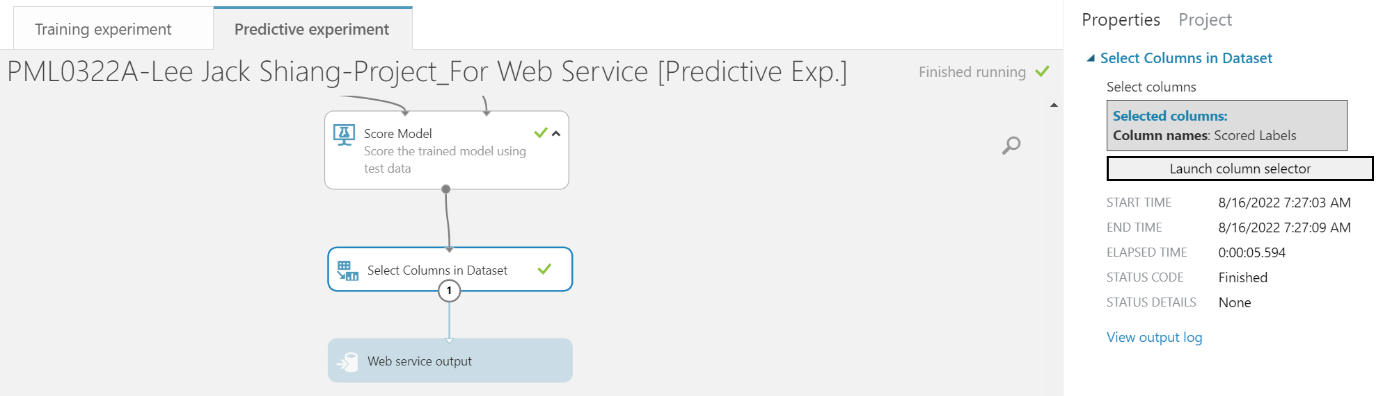

Task 3: Save and run the modified predictive experiment, and then deploy the web service.

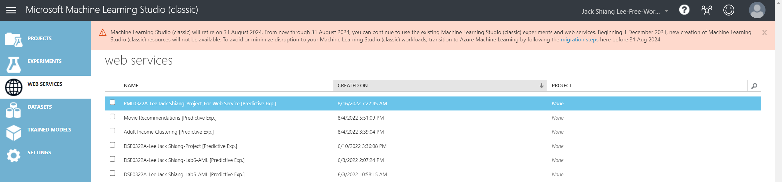

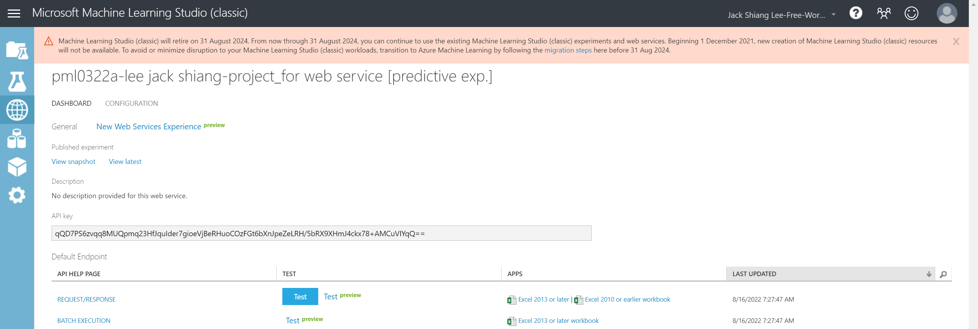

Task 4: Use Excel Online to test the web service, and generate predicted values for the input rows below (Test-Flights.csv’)



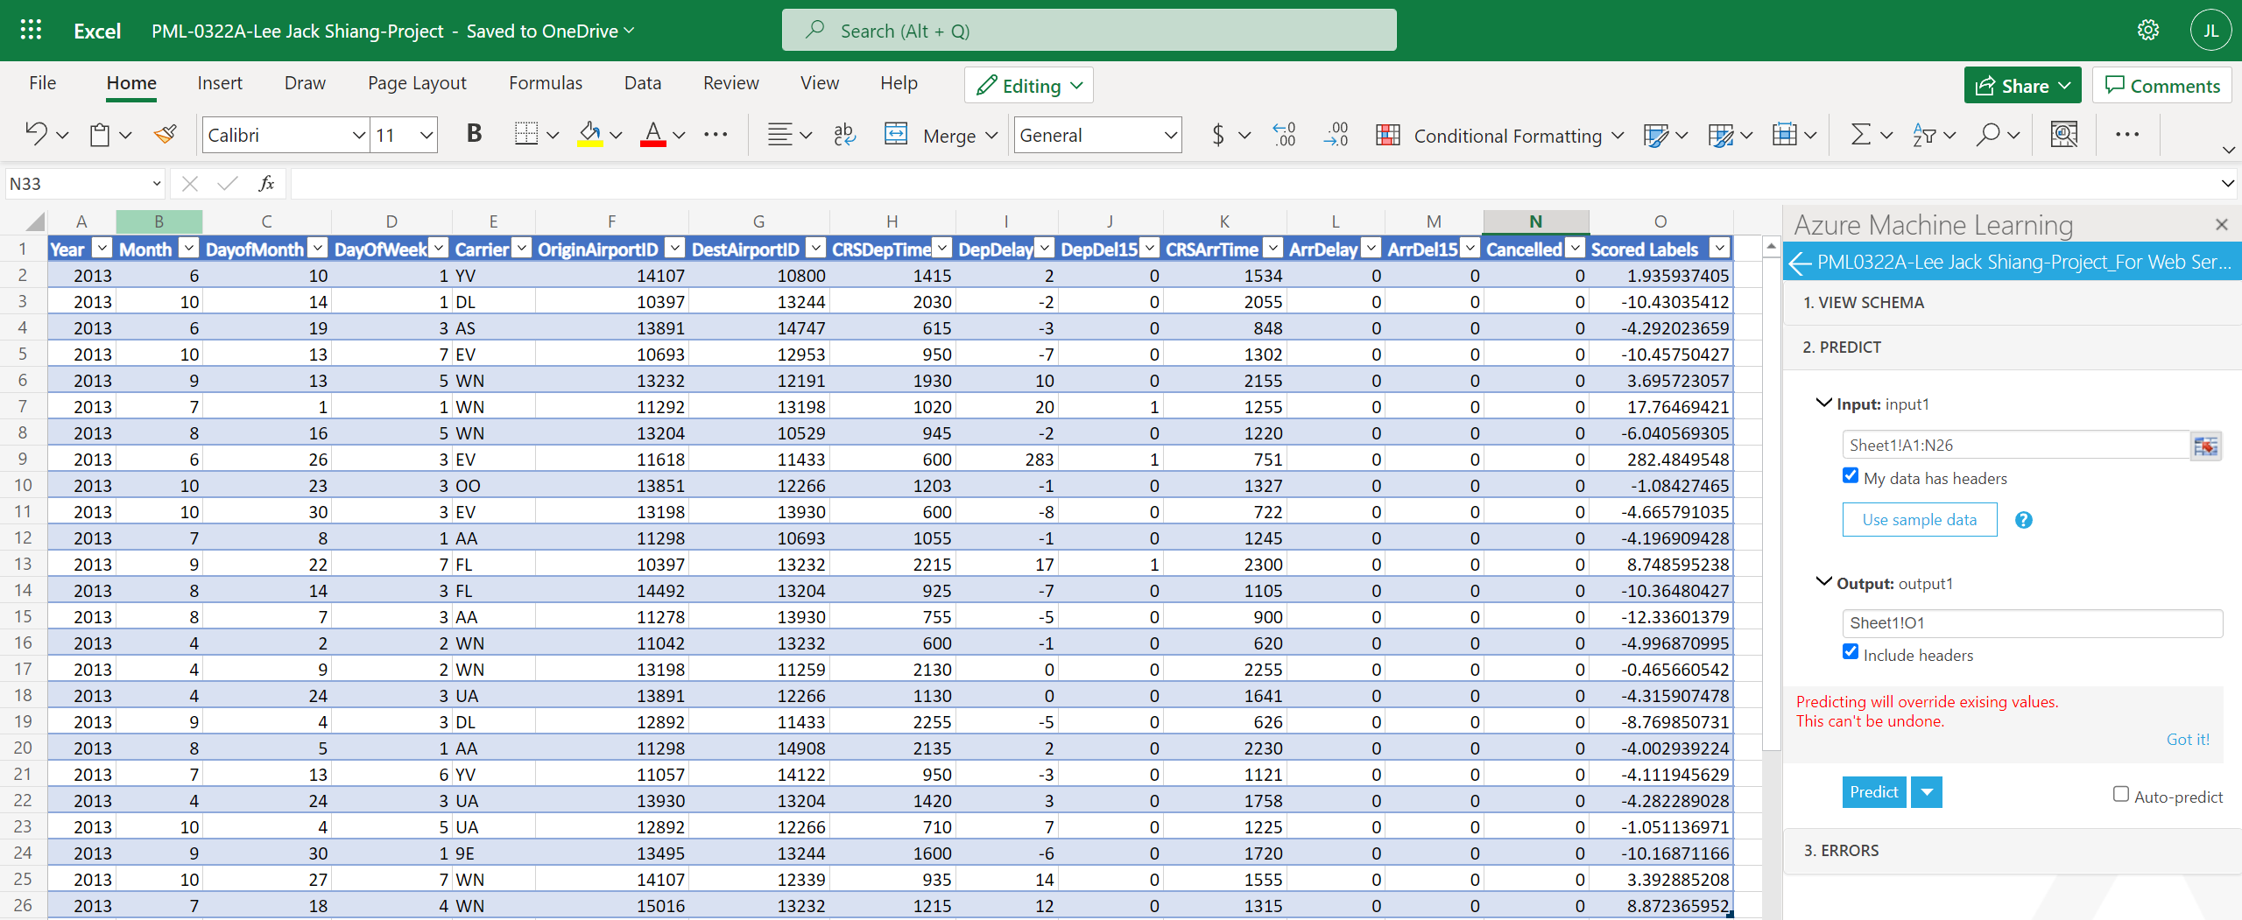

Task 5: Enter the values predicted by your model for each input row:

Input Row 1: 1.935937405

Input Row 2: -10.43035412

Input Row 3: -4.292023659

Input Row 4: -10.45750427

Input Row 5: 3.695723057

Input Row 6: 17.76469421

Input Row 7: -6.040569305

Input Row 8: 282.4849548

Input Row 9: -1.08427465

Input Row 10: -4.665791035

Input Row 11: -4.196909428

Input Row 12: 8.748595238

Input Row 13: -10.36480427

Input Row 14: -12.33601379

Input Row 15: -4.996870995

Input Row 16: -0.465660542

Input Row 17: -4.315907478

Input Row 18: -8.769850731

Input Row 19: -4.002939224

Input Row 20: -4.111945629

Input Row 21: -4.282289028

Input Row 22: -1.051136971

Input Row 23: -10.16871166

Input Row 24: 3.392885208

Input Row 25: 8.872365952

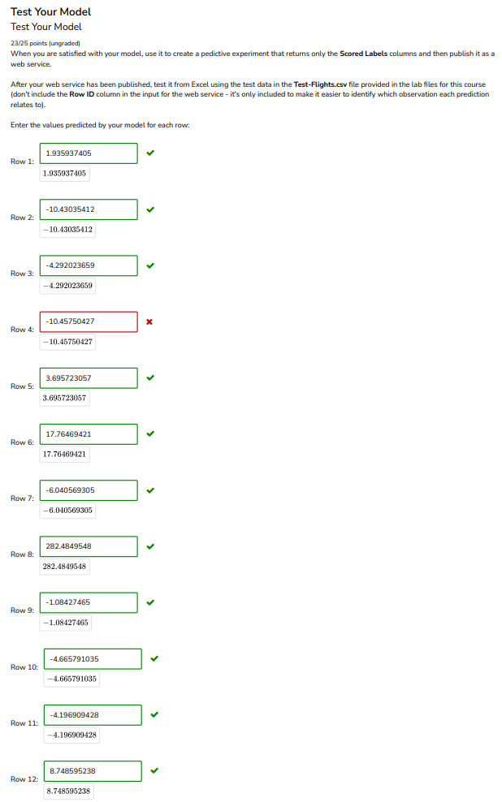 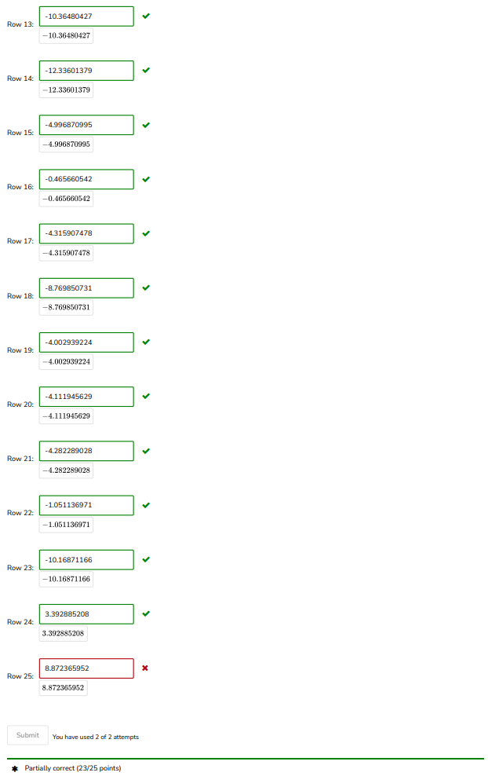

From above, we can see that the optimal model is able to correctly predict ArrDelay within 10 minutes of the actual delay time for 23 out of 25 rows.

1. Conclusion

In this project, it has demonstrated a typical workflow of building a machine learning model using AML studio. From dataset import, data-preprocessing, data visualization, training of the machine learning model, to final model deployment into production, it is possible to build a machine learning model just by using AML studio’s drag and drop tools without any coding (data visualization part can be done using other software, such as PowerBI, Tableau, Excel etc). In addition, the performance of the base model has also been improved substantially by using reverse engineering techniques, such as feature selection, handling for outliers, hyperparameter tuning etc, and cross-validation check to verify that the optimal model is well generalized and ready for real world data. Finally, the optimal model was published as a web service and it was able to correctly predict ArrDelay within 10 minutes of the actual delay time for 23 out of 25 rows of the test data ‘Test-Flights.csv’.

1. Annexure – 01 (Screenshots of Experiment for Reverse Engineering)

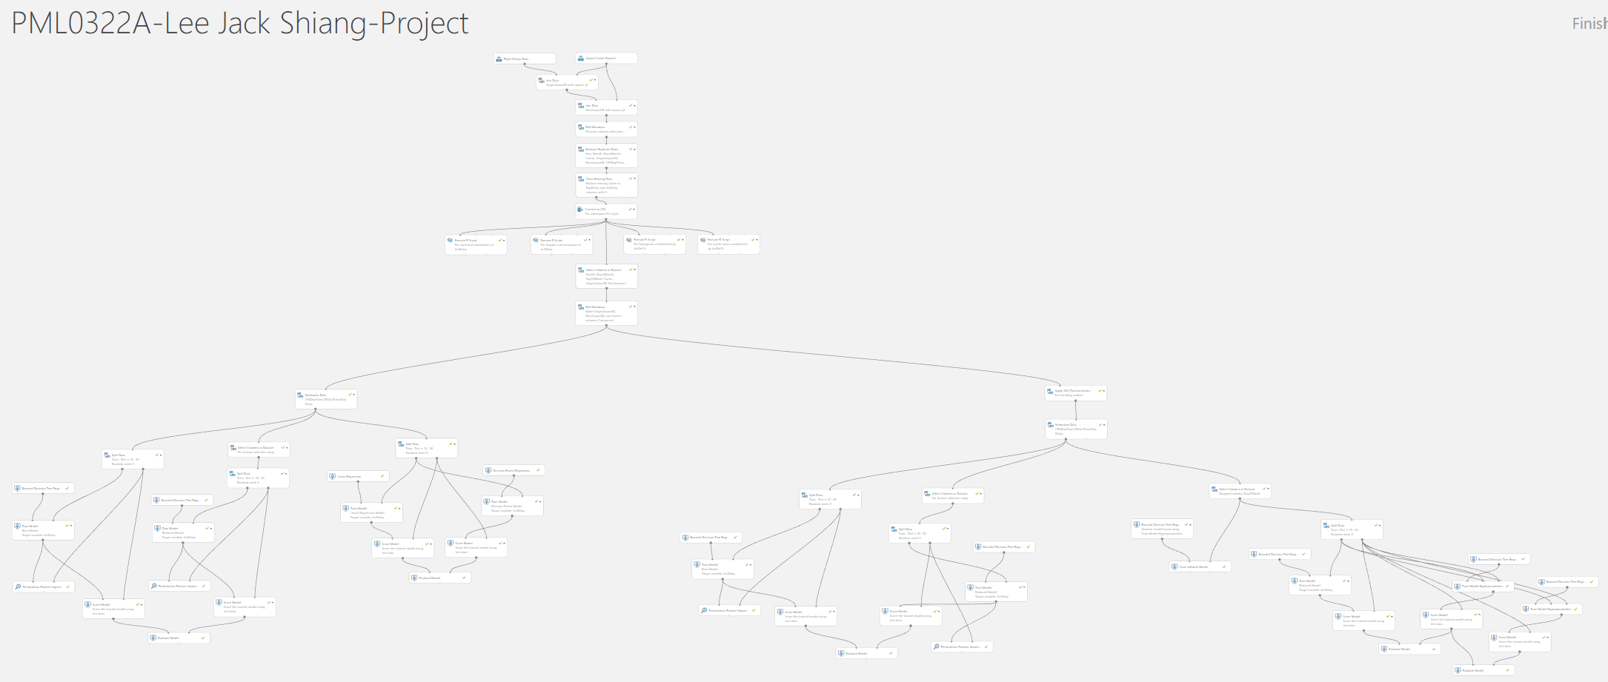

Part 1: For data preprocessing and cleansing

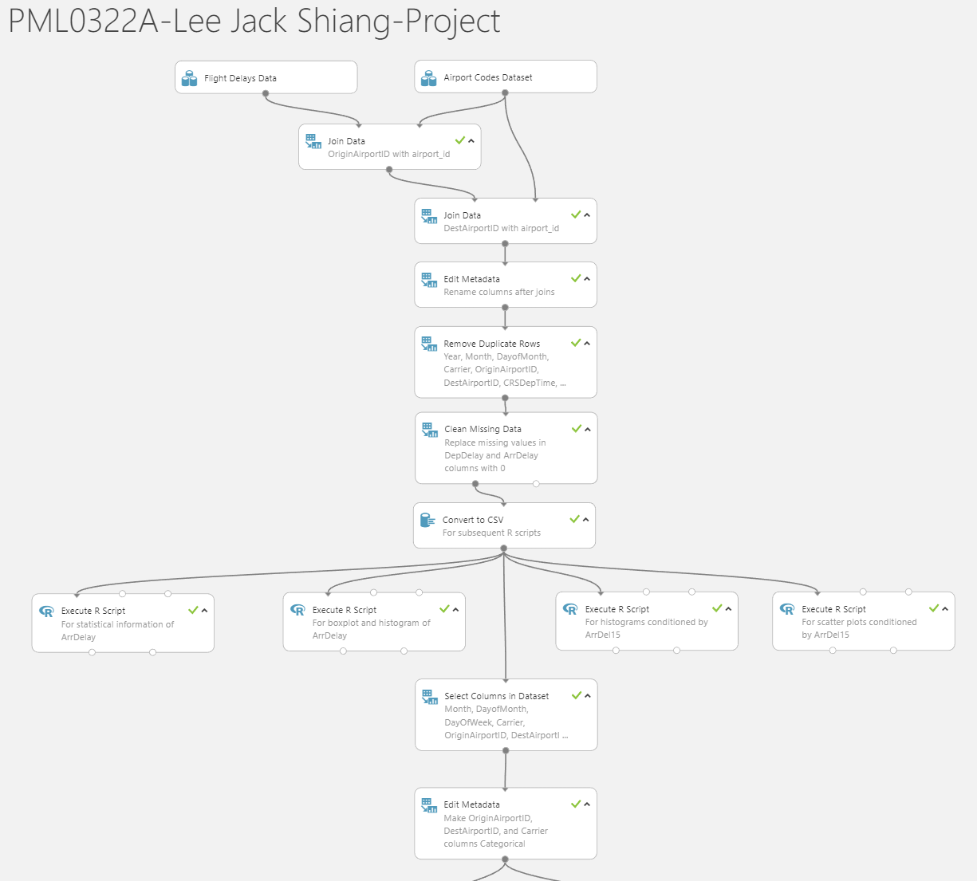

Part 2: For feature selection of the base model, comparison of different algorithms (no handing for outliers)

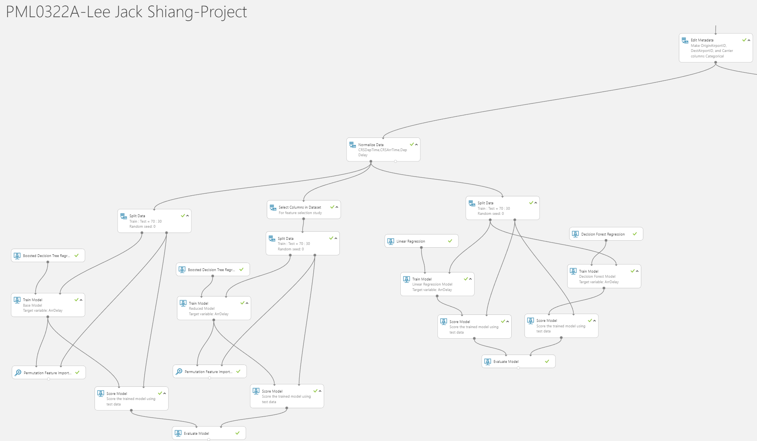

Part 3: For feature selection of the base model (outliers are handled)

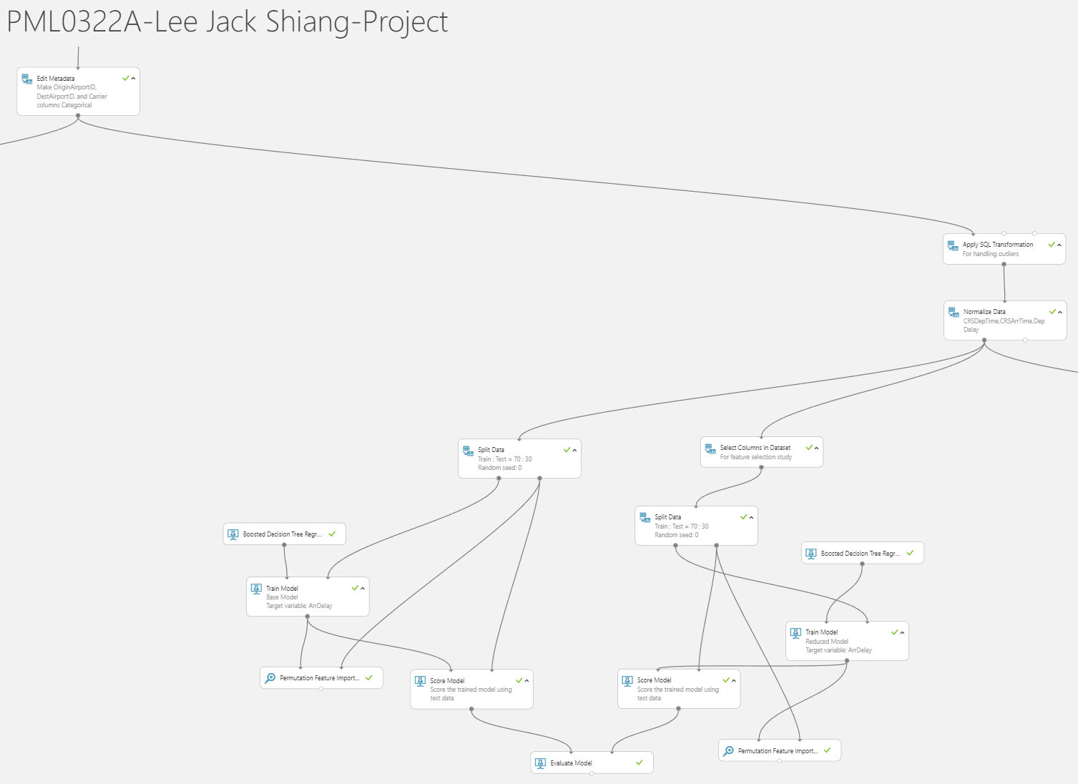

Part 4: For hyperparameter tuning, cross-validation of the optimal model (outliers are handled)

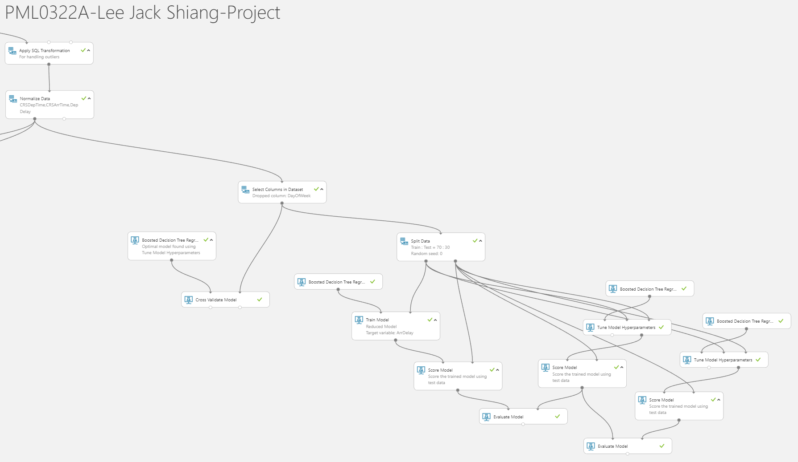

1. Annexure – 02 (Screenshots of Web Service of the Optimal Model)

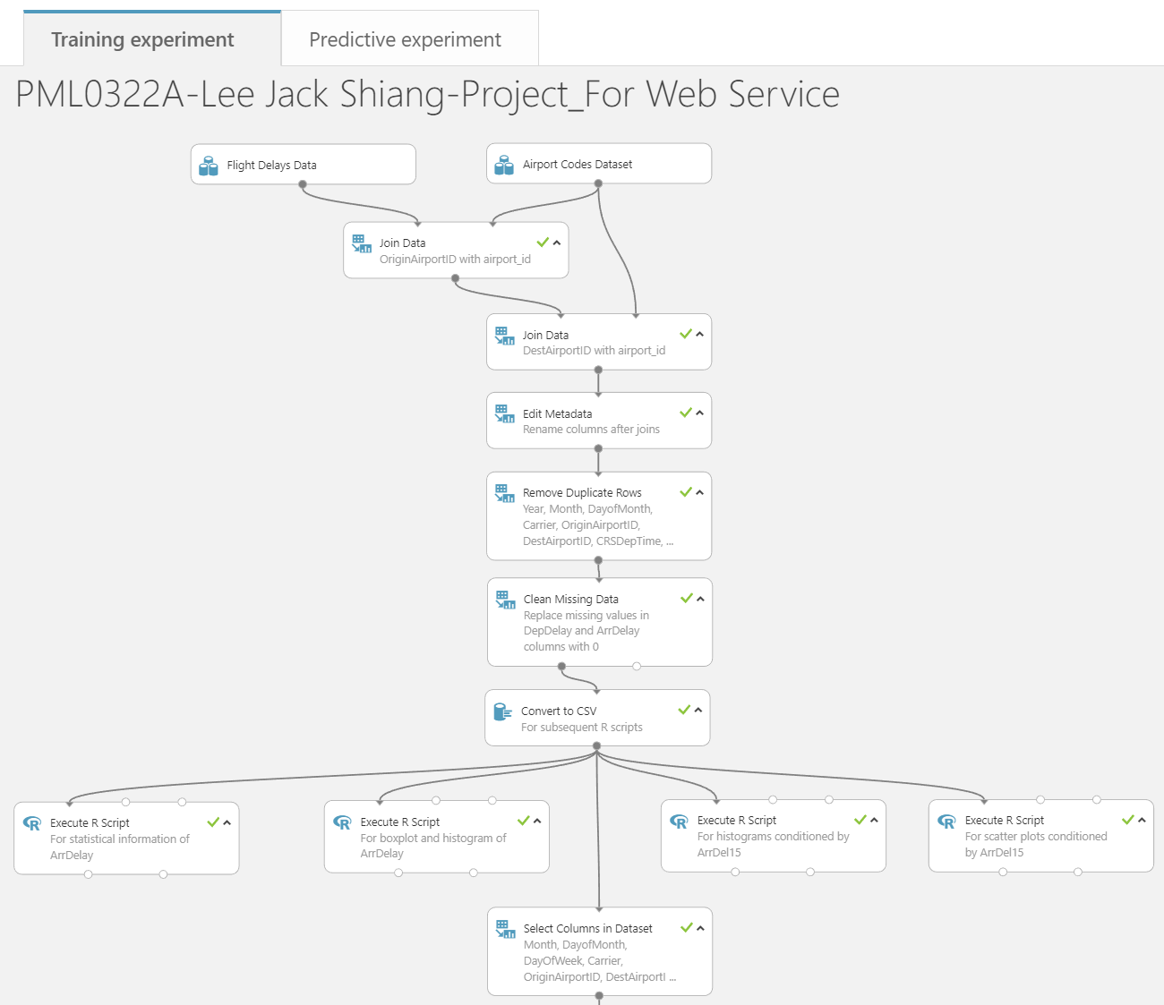

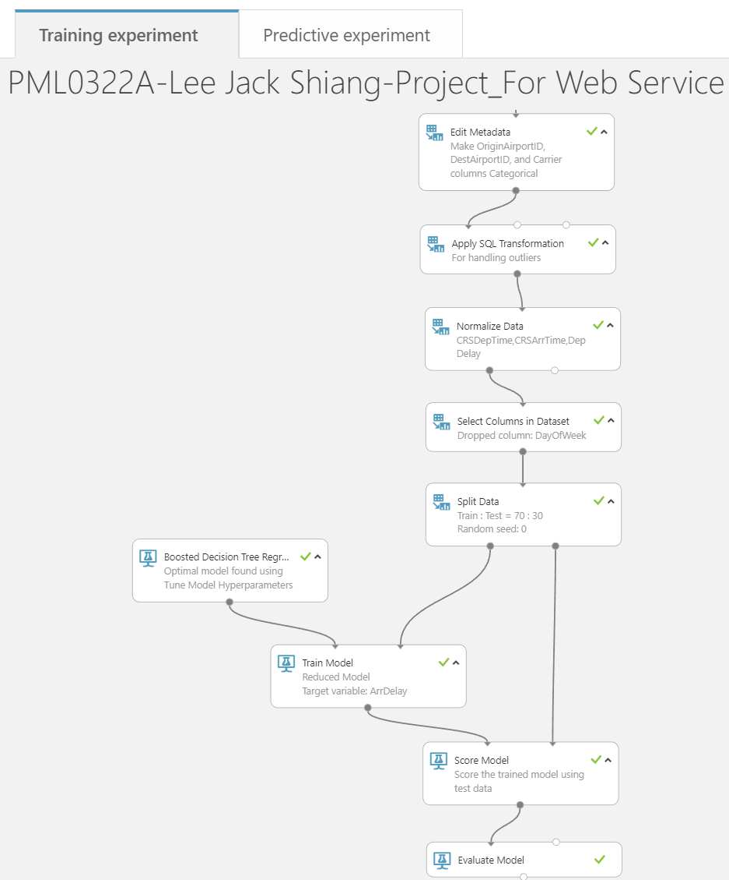

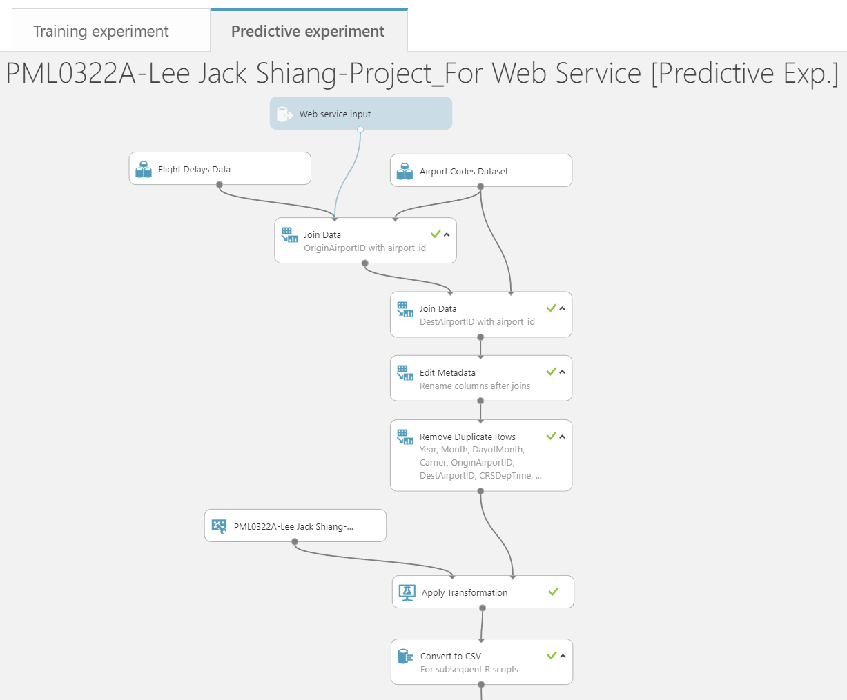

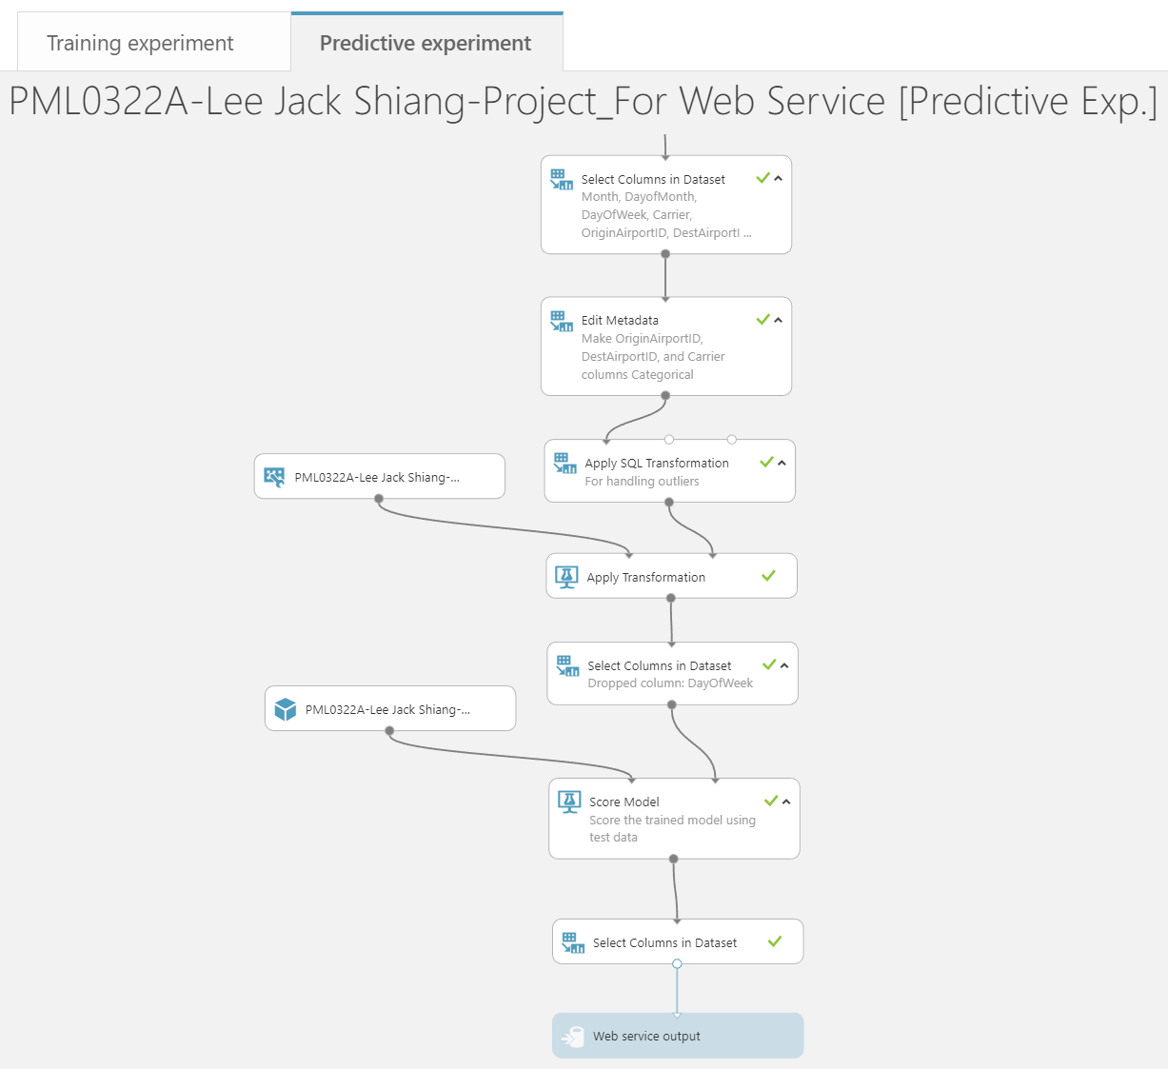

REQUEST/RESPONSE link and API key of the model for Azure Machine Learning Add-ins in Excel Online:

REQUEST/RESPONSE link:

<https://studio.azureml.net/apihelp/workspaces/6587b92216804c8dbe342b49760300e2/webservices/1363d1717a354882ad02604817383bb4/endpoints/1d7da465c667494e89056ead3b9a1fda/score>

API key:

qQD7PS6zvqq8MUQpmq23HfJquIder7gioeVjBeRHuoCOzFGt6bXnJpeZeLRH/5bRX9XHmJ4ckx78+AMCuVIYqQ==